WHA Behavioral Health Manual
Workflow contacts: Katie Snow, Kearsten Kozma, Tina Sartain, Bianca Caruso, Ivy Rose Cardillo
*Clinician workflows highlighted in Green
Table of Contents
BH Workflows: To jump to a workflow, press CTRL and click desired link below
Section A: Entry to care workflows for BH therapy
- Workflow A1: Referral to Behavioral Health
- Workflow A2: Above the Line/Below the Line and Triage Decision Grid
- Workflow A3: Calling, referring out and scheduling patients referred to behavioral health
- Workflow A4: Triage Consults
- Workflow A5: Scheduling Patients for a BH Consult/adding patients to BHC caseloads
- Workflow A6: Adding Medication Assisted Treatment/MAT patients to caseloads
- Workflow A7: Behavioral Health Caseload Management
- Workflow A8: Behavioral Health Consult No Show Workflow
- Workflow A9: Triage Visit No Show Workflow
- Workflow A10: Addressing urgent mental health needs for patients NOT eligible for triage/BH care (BTL)
Section B: Established therapy patient workflows
- Workflow B1: Model of therapeutic care
- Workflow B2: Scheduling follow up visits
- Workflow B3: Addressing urgent needs for established therapy patients or patients on WL
- Workflow B4: No Show Workflow for Return Visits
- Workflow B5: BH FMLA workflow
- Workflow B6: Caseload Review
Section C: Exit from therapy
- Workflow C1: Addressing Closure with Patients
- Workflow C2: Assessing and documenting functioning at closure, documenting closure plan
- Workflow C3: Circumstances in which re-entry to care is warranted, parameters
- Workflow C4: Referrals and case management
Section D: Well-being assessment (WBA) workflow
- Workflow D1: Visit types that include completion of the WBA
- Workflow D2: WBA questions that generate alerts
- Workflow D3: WBA Follow up documentation
Section E: Perinatal Care Coordination Workflows
- Workflow E1: Entry to Perinatal Care Coordination Workflow
- Workflow E2: High Risk Criteria
- Workflow E3: Perinatal Care Coordination/Case Management Workflow
PMHNP Workflows
Section F: Entry to PMHNP Care workflows
- Workflow F1: Referral to BH with PMHNP request by medical provider
- Workflow F2: Referral to Psychiatry by BHC/BHCC
- Workflow F3: Level of Care
- Workflow F4: Review of Referral to Psychiatry
- Workflow F5: Psychiatric Case Review for High risk OB & PP Patients
Section G: Established PMHNP patient workflows

Program Information
Section H: Behavioral Health Program Goals & Roles
- Behavioral Health Program Statement
- Perinatal Behavioral Health Clinician Job Description
- Lead Behavioral health Clinician Job Description
- PMHNP Job Description
- BHCC Job Description
- BH PSR Job Description

Behavioral Health Therapy Workflows

Section A: Entry to Care

Workflow A1: Referral to Behavioral Health
Medical provider, RN or BHC discusses a referral to behavioral health therapy or PMHNP care with the patient and the patient accepts the referral. Patients with “below the line” referral reasons are notified by referring provider that they will receive referral resources to access care outside of WHA.
- Medical provider, RN or BHC enters referral “Referral to Behavioral Health/Behaviorists (WHA)”. Referring provider answers all referral questions completely.
- Behavioral Health Care Coordinator (BHCC) receives internal referrals for behavioral health or PMHNP in “Behavioral Health Referral Order” workqueue. Referrals that have a status of “Ready for Initial Scheduling” require review, attending to those with an “urgent” level of priority first. The BHCC incorporates information from provider comments, eligibility decision grid, and a thorough chart review to determine appropriate action. Referrals are typically reviewed the same day as they are entered unless entered very late in the day.
- BHCC conducts a thorough review of patient information to determine above the line (ATL)/below the line (BTL) criteria for eligibility of Behavioral Health or PMHNP services.
  - Of particular interest are relevant clinical data such as medications, diagnoses, WBA/EPDS data, and recommendations (WL, triage, refer) included in the ‘Provider Comments’ section of the referral notes.
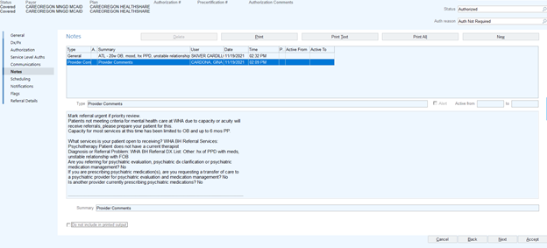
  - If the referring provider has not completed all required fields of the referral, the BHCC sends a message to the referred by provider with a request to complete, clarify, or update the referral information by sending an ‘In Basket Message’ from the referral shell using the .dotphrase BHCCREFCLARITY.
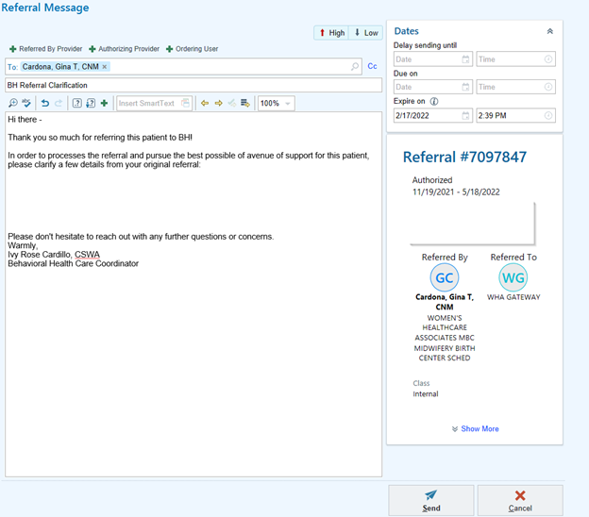
  - When further information is needed to complete the referral review, beyond what the provider can provide, the BHCC conducts a warm handoff with the patient to ask any clarifying questions and assess need.
    - BHCC places a new ‘General’ note in the referral indicating intent to contact patient and requesting BHPSR wait for further instructions.
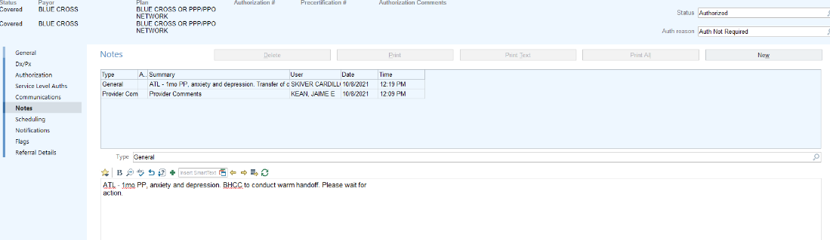
    - BHCC creates a ‘BH Warm Handoff Phone’ appointment for the patient and adds it to their schedule with the APPT Notes ‘Warm Handoff – BH Referral.’
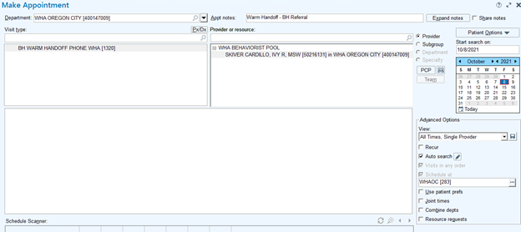
      - Within the appointment encounter, the BHCC indicates ‘Reason for Call’ as ‘Outreach: BH Referral’ and documents the result of outreach. The dotphrase (.BHCCREFASSESSMENT) is available to utilize for documentation.
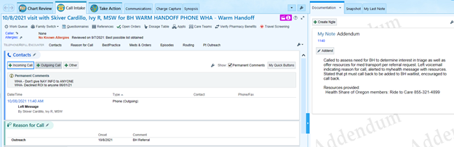
      - If unable to reach the patient during attempt one, the BHCC right clicks on the patient in the workqueue and selects ‘Defer.’ The ‘Reason’ for deferment is filled in as ‘Patient Contact.’ The referral is deferred for 7 days from the outreach attempt.
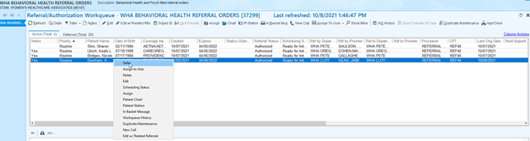
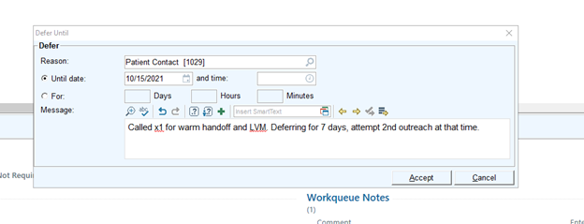
      - After the 7-day deferment, the referral will return to the workqueue with a ‘Scheduling Status’ of ‘Called x1.’
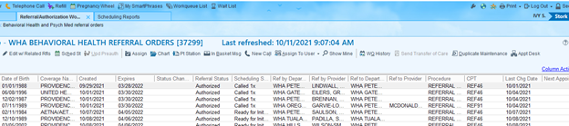
        - If the patient has not returned call by the time the referral returns to the workqueue, the BHCC makes second attempt for contact. If the patient is not reached on the second outreach attempt, the referral is deferred for 7 more days.
      - After the second 7-day deferment, the referral will return to the workqueue with a ‘Scheduling Status’ of ‘Called x2.’
        - If the patient has not returned call by the time the referral returns to the workqueue, the BHCC sends a myhealth message with referral resources (.WHAMHREFER), notifying of final attempt for contact, and requesting callback. The referral is deferred for 7 more days.
      - If the referral enters the workqueue a third time without patient contact, the BHCC sends an ‘In Basket Message’ from the Referral Shell to ‘WHA Patient Services Behavioral Health Pool’ requesting that referral is closed. The patient has 30 days after the initial referral entered to call back and be eligible for services even if the referral has been closed.
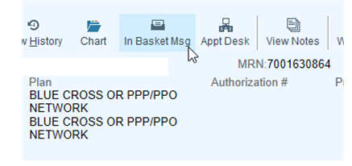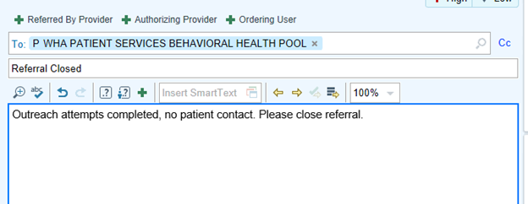
    - Once the patient has been contacted and necessary action has been determined, BHCC follows step 5 as well as sends an ‘In Basket Message’ within the Referral Shell to ‘WHA Patient Services Behavioral Health Pool’ with updated action.
    - Note: The BHCC must check daily for reactivated referrals for which the BHCC has taken responsibility to conduct outreach
  - If upon review of patient information, it is apparent the patient has seen a WHA therapist within the last 6 months, the patient is eligible to be scheduled for a follow up appointment. The BHCC indicates this as the action step in a new ‘General’ note in the referral.
- When patient information has been reviewed, the BHCC determines eligibility status by referring to Workflow A2: Above the Line/Below the Line and Triage Decision Grid: as well as deciding on appropriate affiliated action.
Options for action instructions are based on eligibility:
  - Above the Line options to note in referral instructions to PSR:
    - Waitlist & Referral Resources (.WHAMHREFER)
    - Triage, Waitlist & Referral Resources (.WHAMHREFER)
      - Indicate “Urgent Triage” to recommend patient has stabilization appointment within 2-3 business days
      - Indicate “Non-Urgent Triage” to recommend patient has stabilization appointment but can wait for next available within 10 business days
    - Any specific information or referrals in addition to standard
  - Below the Line options to document in referral instructions to PSR
    - Referral Resources (.WHAMHREFER)
    - Any specific information or referrals in addition to standard
- The BHCC creates a new ‘General’ note in the Referral Shell indicating pertinent information gathered from the review, ATL/BTL status, as well as action instructions for the BHPSR. BHCC “accepts” the note changes and returns to workqueue list.
  - For example: “ATL - 32w OB, depression, hx birth trauma. Non-Urgent Triage, Waitlist, and MHREFER.”
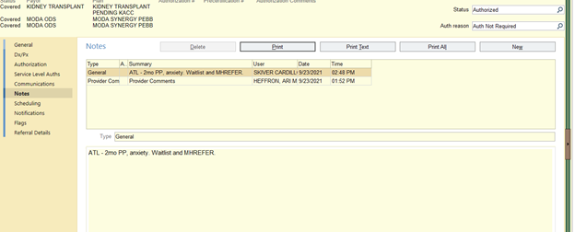
- BHCC right clicks on the patient and selects “notes.” The note must have a summary of status or plan using the following options: “ATL,” “BTL,” or “Wait for Action.” Once accepted, this note will add a “Yes” in the far-left column, notifying the BH PSR that the referral is ready to be called and offered the services outlined.
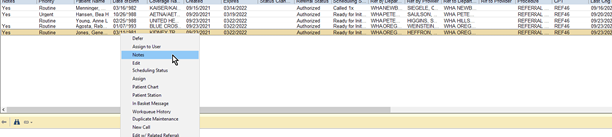
- Once the BH PSR has completed the workflow and conducted outreach for scheduling triage or waitlist patients but has been unsuccessful in contacting the patient, the BH PSR follows the workflow that indicates closing the referral. The BH PSR sends a message stating ‘FYI closing referral’ to the BHCC to notify of all referral closures for ATL patients. The BHCC receives these messages in the EPIC ‘Referral Messages’ pool.
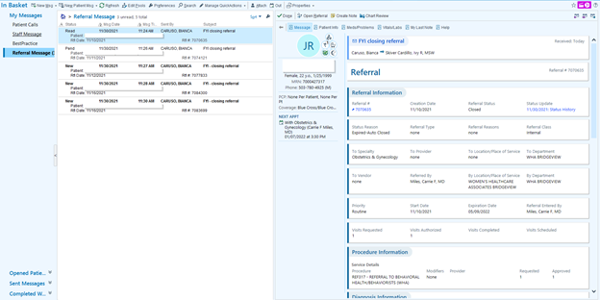
  - The BHCC conducts a brief chart review of the messages in order to determine if extenuating circumstances apply in which the patient may be contacted outside of the regular workflow or if notifying the provider of the unsuccessful attempts for contact is necessary.
  - If the BHCC determines the referral closure is appropriate and no further action is needed, the BHCC deletes the message.
  - If the BHCC determines that the provider would benefit from information regarding the closed referral, the BHCC forwards the FYI message to the ‘Referred by Provider’ using the .dotphrase BHCCREFCLOSE.
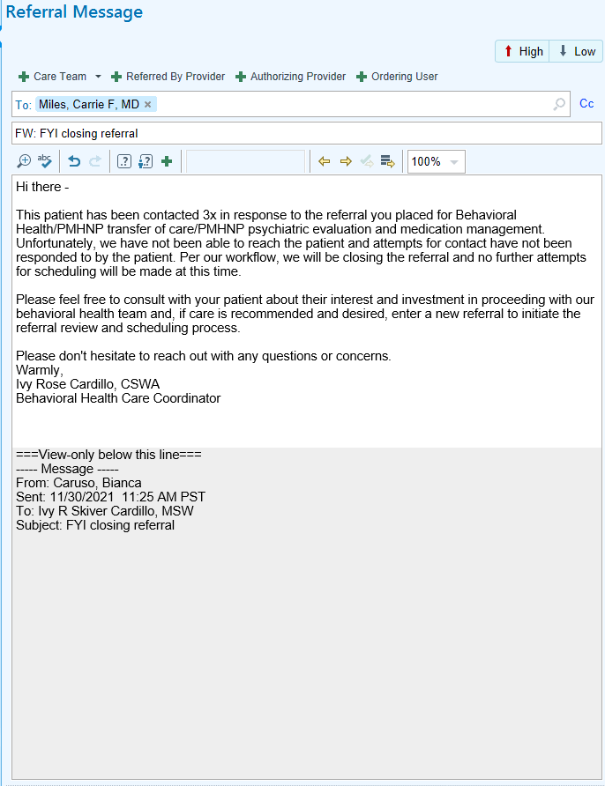

Workflow A2: Above the Line/Below the Line and Triage Decision Grid
Above the line= Eligible for behavioral health care at WHA (waitlist or therapist assignment if openings) and receive referral list if pt wishes to shop around for care.
Below the line= Not eligible for behavioral health care at WHA, receive referral list and additional tailored referrals for specific requests
Urgent Triage= Adverse u/s findings, Options counseling or post-TAB support, Neonatal loss, Baby in NICU, thoughts of self-harm with plan or intent, EPDS 12 or above, Provider and/or Patient indicates urgency. There are other situations when an urgent triage is needed, and these decisions require clinical judgement based on information available.
Referral Reason | Triage eligible | Above the line: | Below the line
OB or PP (<6mo PP at time of referral)  High acuity: triage eligible  - EPDS or PHQ9 12 or above or Suicidal Ideation  - Bipolar disorder, OCD, eating disorder or borderline personality diagnosis suspected or confirmed  - Hx postpartum psychosis or suspected current PPP  - Substance abuse  - Tobacco use-OB  - Gestational diabetes with poor management due to mental health  - Adverse u/s findings  - Options counseling or post-TAB support  - Neonatal loss  - Baby in NICU  - Provider indicates urgency  - Pt expresses urgent need to BH PSR without additional criteria met (must be OB or <6 mo PP) | x | x
OB or PP (<6mo PP at time of referral)  Lower acuity: triage not usually indicated  - EPDS or PHQ9 below 12 or no information on acuity  - Recurrent SAB |  | x
Gyn tobacco cessation required for elective surgery | x | x
Gyn physical health concern impacted by mental health  - Pelvic pain  - PMDD  - Menopausal symptoms |  |  | x
Gyn mental health and substance abuse concerns |  |  | x

Workflow A3: Calling, referring out and scheduling patients referred to behavioral health
BH PSR gets ready to call a patient from the BH referral queue. Each referral will first be reviewed by the BHCC (Behavioral Health Care Coordinator) and will have a “yes” next to the referral under the notes column once the referral is ready to be called
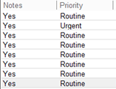
  - Important to work the “urgent” referrals as first priority, then move onto the “routine” referrals

- Above the line (ATL) patients qualify for therapy at WHA: triage appointment and/or waitlist and resources
- Below the line (BTL) patients do not qualify for therapy at WHA: refer out/send external resources (WHAMHREFER) via myhealth or mail letter
- BH PSR makes 1st outreach to patient that qualifies for a triage appointment, waitlist, and resources
- BH PSR notes in the referral shell what the referral qualifies for (use dot phrase WHABHREFERRALREVIEW)
  - In this case, patient's referral reason is “Above the line” and patients' referral reason is “one time triage consult with WHA BH provider”

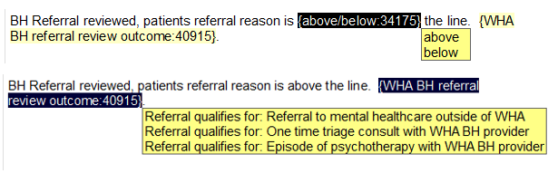
- If the patient answers and qualifies for a triage appointment, waitlist, and resources
    - BH PSR uses scripting to describe triage appointment to the patient:
"In addition to adding you to the waitlist, I have an opening for you to speak with a licensed therapist to discuss any urgent needs and for someone to provide immediate support and coping strategies for you. The intention of this visit is to better understand your urgent needs and to help problem-solve quickly. I have an appointment x date/time, would you like to take that appointment?”
    - BH PSR uses the BH Triage Telehealth Visit type if patient accepts and schedules patient in an available “triage” opening within 10 business days or in any open “green” spot within 48 hours with ANY BH provider
    - BH provider can only see 2 triage visits per day
- BH PSR notes in the referral shell the outcome of the call (use dot phrase WHABHREFERRALCALL)
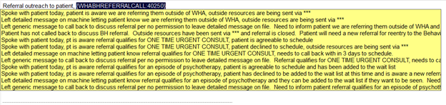
  - In this case, the referral outreach to the patient would be: “Spoke with patient today, pt is aware referral qualifies for one time triage consult, pt is agreeable to schedule”
    - BH PSR sends informed consent to patient for the scheduled one-time triage visit (dot phrase BHTRIAGEINFCONS) via myhealth or mail to patient’s address
    - BH PSR adds the patient to the waitlist for therapy and sends referral resources (dot phrase WHAMHREFER and BHPSRHOMEVISITING for OB/PP patients) via myhealth or mail
      - Wait list note should be the same as BHCC’s referral review note
        - example: “ATL - 8wk OB, anxiety and depression, wait list and resources” and add when the triage visit is scheduled
      - Reminder to always add a triage patient to the wait list even if the referral review doesn’t say so
        - Except for: Yamhill County insured patients, these patients can only be seen for a one-time triage visit , not for ongoing therapy as Yamhill County insurance does not cover mental health services at WHA. Yamhill patients should also receive the .BHYAMHILL resource list.
- BH PSR starts phone encounter to document the same information as the referral shell
    - Contact: Choose outgoing call, self/patient, bolded preferred number, left message or not available (leave this portion blank if you spoke with pt)
    - Reason for call: “Referral” and Comment: “BH Scheduling Outreach”
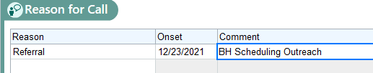
    - Documentation:
      - Start phone note documentation with: Referral placed [date referral was entered] by [provider who entered the referral]
      - Copy and paste in the notes from the referral shell (referral review and referral outcome of the call)
      - Add any extra notes that are particular to the patient's situation (example below)
    - Always sign encounter when done, no need to route it anywhere
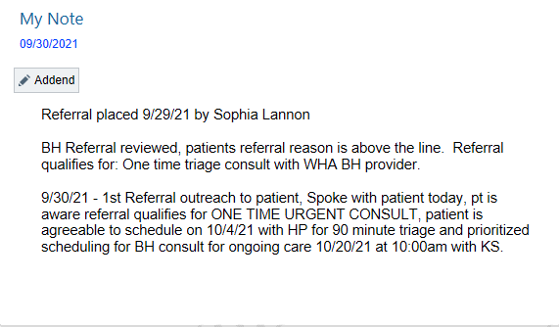
IMPORTANT: Always update the phone encounter for each outreach attempt or new action for every BH referral such as triage scheduling or WL addition, or if patient calls back and declines a BH service, etc. Whatever you write in the referral shell must also go in the BH scheduling outreach phone encounter.
- BH PSR then attaches the referral to the scheduled one-time triage visit
    - Before attaching the referral, the scheduling status of the referral needs to say “ready for initial scheduling”
    - The flag needs to be changed to “close the loop” so that it falls out of the referral queue since the patient has been scheduled
    - Accept out of the referral
    - Go to patients' appointment desk, right click the one-time triage visit, click “assign referral”, choose the correct BH referral as a patient can have many different referrals for other services on file and click “assign” on the top of the screen with a green check mark next to it

- If patient answers and declines the triage visit, but accepts wait list and resources
- BH PSR Follow steps 1 and 2 from above
- BH PSR notes in the referral shell what the referral qualifies for (WHABHREFERRALREVIEW)
- BH PSR notes in the referral shell the outcome of the call (WHABHREFERRALCALL) specifying that the patient declined the one-time triage visit and note reasoning if patient provided one
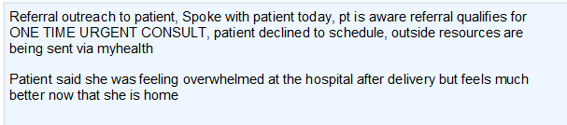
- BH PSR adds the patient to the waitlist for therapy and sends referral resources (WHAMHREFER, BHPSRHOMEVISIT) via myhealth or mail
  - Wait list note should be the same as BHCC’s referral review note adding declined one-time triage visit
    - example: “ATL - Newly PP, depression, wait list and resources, patient declined one-time triage visit”
- BH PSR starts phone encounter to reflect the same information as the referral shell
    - Contact: choose outgoing call, self/patient, bolded preferred number, left message or not available (leave this portion blank if you spoke with pt)
    - Reason for call: “Referral” and Comment should note: “BH Scheduling Outreach”
    - Documentation:
      - Start phone note documentation with: Referral placed [date referral was entered] by [provider who entered referral]
      - Copy and paste in the notes from the referral shell (referral review and referral outcome of the call)
    - Add any extra notes that are particular to the patient's situation
    - Always sign encounter when done, no need to route it anywhere
- BH PSR then closes the BH referral once the documentation is complete because the patient has been added to the BH wait list, and resources have been sent via myhealth or mail
  - How to close a referral:
    - Scheduling status needs to be changed to "do not schedule"
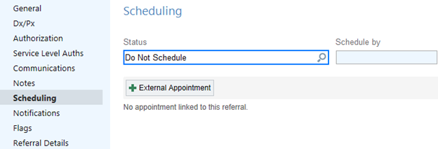
    - Top right of referral, change the status from “authorized” to closed"
    - Under status, change the auth reason from “auth not required” to "expired-auto closed"
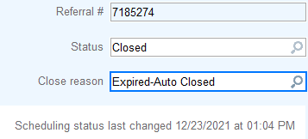
    - Lastly, the flag needs to be changed to "close the loop"
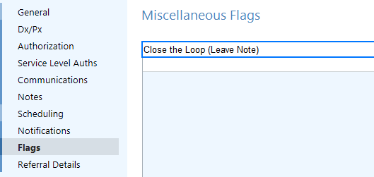
    - Accept out of the referral and now the referral is closed

- If patient doesn’t answer to 1st outreach and qualifies for one-time triage and/or wait list, and resources
    - BH PSR gets ready to call the patient from the referral queue. Go to the patients account first and check the permanent comments section on the appointment desk to see if the patient gave permission to leave a detailed voicemail or not before calling. Example of a patient giving permission below:

    - BH PSR makes 1st outreach attempt to patient
      - Detailed voicemail scripting for triage and wait list:
“Hello, I am calling from Women’s Health Care Associates regarding the behavioral health referral that was entered by your WHA provider. We would like to offer you an appointment to have any of your urgent needs assessed as we do have a wait list to right now to see one of our licensed therapists for ongoing therapy. Please give our office a call at 503-657-1071 to discuss this referral in more detail. Thank you”
      - Detailed voicemail scripting for wait list:
“Hello, I am calling from Women’s Health Care Associates regarding the behavioral health referral that was entered by your WHA provider. We do have a wait list to right now to see one of our licensed therapists for ongoing therapy. We would be happy to add you to the wait list, but we do need you to call us back and confirm that is what you would like to proceed with. Please give our office a call at 503-657-1071 to discuss this referral in more detail. Thank you”
      - Generic voicemail scripting for triage and/or wait list:
“Hello, I am calling from Women’s Health Care Associates regarding a referral we received. We have some additional information we would like to go over with you, please give our office a call back to discuss further at 503-657-1071. Thank you”
    - BH PSR notes in the referral shell what the referral qualifies for (WHABHREFERRALREVIEW)
    - BH PSR notes the outcome of the call (WHABHREFERRALCALL) in the referral shell
    - BH PSR changes the scheduling status of the referral to “Called 1x” and accepts out of the referral
    - BH PSR defers referral out for 7 days (go back to the referral queue, right click the referral you want to postpone, “reason” is patient contact and the “until date” is one week out from today)
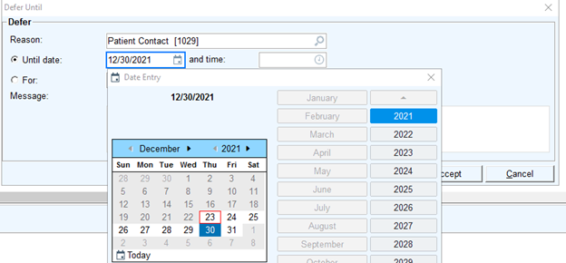
    - Update BH scheduling outreach phone encounter
- If patient doesn’t answer to 2nd outreach and qualifies for one-time triage and/or wait list, and resources
    - BH PSR gets ready to call the patient again when the referral re-enters active referral queue after 7 days. Go to the patients account first and check the permanent comments section on the appointment desk to see if the patient gave permission to leave a detailed voicemail or not before calling. Example of a patient giving permission below:
    - BH PSR makes 2nd outreach attempt to patient
      - Detailed voicemail scripting for triage and wait list:
“Hello, I am calling from Women’s Health Care Associates regarding the behavioral health referral that was entered by your WHA provider. We would like to offer you an appointment to have any of your urgent needs assessed as we do have a wait list to right now to see one of our licensed therapists for ongoing therapy. Please give our office a call at 503-657-1071 to discuss this referral in more detail. This is our second attempt to reach you regarding this referral, we will give you one more week to call back before closing out the referral completely. Thank you”
      - Detailed voicemail scripting for wait list:
“Hello, I am calling from Women’s Health Care Associates regarding the behavioral health referral that was entered by your WHA provider. We do have a wait list right now to see one of our licensed therapists for ongoing therapy. We would be happy to add you to the wait list, but we do need you to call us back and confirm that is what you would like to proceed with. Please give our office a call at 503-657-1071 to discuss this referral in more detail. Thank you”
      - Generic voicemail scripting:
“Hello, I am calling from Women’s Health Care Associates regarding a referral we received. We have some additional information we would like to go over with you, please give our office a call back to discuss further at 503-657-1071. This is our second attempt to reach you regarding this referral, we will give you one more week to call back before closing out the referral completely. Thank you”
    - BH PSR notes the outcome of the call (WHABHREFERRALCALL) in the referral shell (no need to write what the referral qualifies for again as this was entered already at the 1st scheduling outreach)
    - BH PSR changes the scheduling status of the referral to “Called 2x” and accepts out of the referral
    - BH PSR defers the referral out for 7 more days to give the patient one more week to call us back (go back to the referral queue, right click the referral you want to postpone, reason is “patient contact” and the until date is one week out from today)
    - BH PSR sends patient a myhealth message after the second outreach attempt requesting patient to call us back to discuss BH referral (dot phrase WHABHREF2NDCALL):
“Dear [insert patient name], We attempted to reach you by phone for the second time today and have been unable to reach you. You have been referred to the Behavioral Health Team here at WHA and we need to discuss the referral in further detail. If we do not hear back from you within the week, we will close out your referral and you will need a new referral from your WHA provider to enter our Behavioral Health program. Thank you, [insert your name] -WHA scheduling”
    - BH PSR updates the BH scheduling outreach phone encounter
    - When the referral re-enters the referral queue after the second deferment and the patient has still not called back to discuss the referral and/or to schedule, the referral now needs to be closed
    - BH PSR updates the referral shell with closing referral documentation
    - Closing referral documentation:

“Attempted to reach patient 2x [insert dates for outreaches] to offer [one-time triage] and/or [BH wait list]. Patient has not called back to discuss BH referral and/or to schedule. Outside resources have been sent via myhealth and referral is now closed.

If patient calls back within one week [insert date], patient can be added to the bottom of the wait list. If patient calls back after [insert same date], patient will need a new referral for reentry to the Behavioral Health Program at WHA. Patient will then need to go through the referral review process and wait list again.”

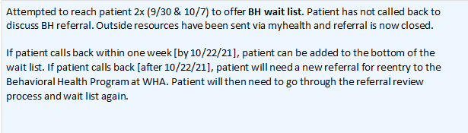

    - If a patient returns a call within 30 days of initial referral entry, they will be eligible to be added to the bottom of the waitlist and/or have a triage visit if appropriate based on patients' needs even if referral was closed. If a patient calls back after 30 days, the patient will need a new referral from their WHA provider and will need to go through the referral review and waitlist process again.
    - BH PSR updates the BH scheduling outreach phone encounter with the same information
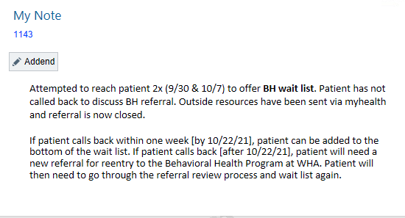
    - BH PSR routes staff message to BHCC to indicate the closure of a referral for a patient who hasn’t responded to outreach attempts that qualified for triage visit and/or waitlist
    - The BHCC conducts a chart review to determine if extenuating circumstances for additional outreach apply or if informing the provider of no response from patient is necessary

- If patient answers and is below the line/qualifies for external resources/refer outside of WHA
- BH PSR follows steps 1 and 2 from above
- BH PSR notes in the referral shell what the referral qualifies for (WHABHREFERRALREVIEW)
- BH PSR uses scripting to explain to the patient why we are referring her outside of WHA for mental health services:
“Hello, I am calling from Women’s Health Care Associates regarding the BH referral that was entered by your WHA provider. At this time, our program is at capacity for taking on new patients to see one of our licensed therapists, but we wanted to make sure that we got you connected with some outside resources that will assist you with finding a mental health provider outside of our office. Would I be able to provide the list of resources to you via myhealth or mail you a copy?”
    - BH PSR notes in the referral shell the outcome of the call (WHABHREFERRALCALL)
    - BH PSR sends resources (WHAMHREFER) to the patient via myhealth or mail
    - BH PSR updates the BH scheduling outreach phone encounter
    - BH PSR then closes the BH referral once the documentation is complete, and the patient has been notified/resources have been sent via myhealth or mail
        - Scheduling status needs to be changed to "do not schedule"
        - Top right of referral, change the status from “authorized” to closed"
        - Under status, change the auth reason from “auth not required” to "expired"
        - Lastly, the flag needs to be changed to "close the loop"
        - Accept out of referral

- If patient doesn’t answer and is below the line/qualifies for external resources/refer outside of WHA
    - BH PSR follows steps 1 and 2 from above
    - BH PSR notes in the referral shell what the referral qualifies for (WHABHREFERRALREVIEW)
    - BH PSR makes 1st outreach attempt to patient
  - if the patient gave permission to leave a detailed voicemail scripting:
“Hello, I am calling from Women’s Health Care Associates regarding the BH referral that was entered by your WHA provider. At this time, our program is at capacity for taking on new patients to see one of our licensed therapists, but we wanted to make sure that we got you connected with some outside resources that will assist you with finding a mental health provider outside of our office. I will send the list of resources to your myhealth portal/or mail you a copy to your address. If you have any questions, please feel free to reach us at 503-657-1071-. Thank you”
    - BH PSR notes the outcome of the call (WHABHREFERRALCALL) in the referral shell
    - BH PSR sends resources (WHAMHREFER) to the patient via myhealth or mail
    - BH PSR updates the BH scheduling outreach phone encounter
    - BH PSR then closes the BH referral once the documentation is complete, and the patient has been notified/resources have been sent via myhealth or mail
        - Scheduling status needs to be changed to "do not schedule"
        - Top right of referral, change the status from “authorized” to closed"
        - Under status, change the auth reason from “auth not required” to "expired"
        - Lastly, the flag needs to be changed to "close the loop"
        - Accept out of referral
  - If the patient did not give permission to leave a detailed voicemail and you must leave a generic voicemail scripting:
“Hello, I am calling from Women’s Health Care Associates regarding a referral we received. We have some additional information we would like to go over with you, please give our office a call back to discuss further at 503-657-1071. Thank you”
    - BH PSR notes the outcome of the call (WHABHREFERRALCALL) in the referral shell
    - BH PSR changes the scheduling status of the referral to “Called 1x” and accepts out of the referral
    - BH PSR defers referral out for 7 days (go back to the referral queue, right click the referral you want to postpone, reason is “patient contact” and the until date is one week out from today)
    - Update BH scheduling outreach phone encounter
    - Follow the same steps again when the referral re-enters the referral queue for a 2nd time. Attempt to reach the patient a second time and defer the referral out for another week if you don’t reach the patient. By the third week, if you can’t leave a detailed voicemail and the patient has still not called back to discuss BH referral, note that in referral shell and phone encounter and close out the referral completely with closing documentation statement.

Workflow: Unable to reach patient closing referral documentation
- Referral qualified for one-time triage visit
Attempted to reach patient 2x (Date, Date) to offer One-time triage visit. Patient has not responded to outreach attempts to schedule. Outside resources have been sent via myhealth or mail to the patient and referral is now closed.
If the patient calls back within one week (Date), the patient’s needs will be assessed and will be reconsidered for scheduling. If the patient calls back after one week (Date), patient will need a new referral for reentry to the Behavioral Health Program at WHA. Patient will then need to go through the referral review process and wait list again.
- Referral qualified for BH wait list
Attempted to reach patient 2x (Date, Date) to offer BH wait list. Patient has not responded to outreach attempts to discuss BH referral in further detail. Outside resources have been sent via myhealth or mail to the patient and referral is now closed.
If the patient calls back within one week (Date), patient can be added to the bottom of the wait list. If the patient calls back after one week (Date), patient will need a new referral for reentry to the Behavioral Health Program at WHA. Patient will then need to go through the referral review process and wait list again.
- Referral qualified for one time triage visit and BH wait list
Attempted to reach patient 2x (Date, Date) to offer One-time triage visit and BH wait list. Patient has not responded to outreach attempts to discuss BH referral in further detail/to schedule. Outside resources have been sent via myhealth or mail to the patient and referral is now closed.
If the patient calls back within one week (Date), patient’s needs will be assessed and will be reconsidered for scheduling and can also be added to the bottom of the wait list. If the patient calls back after one week (Date), patient will need a new referral for reentry to the Behavioral Health Program at WHA. Patient will then need to go through the referral review process and wait list again.
- Removing a patient from the wait list, unable to reach patient documentation (note this information in the referral shell and the BH scheduling outreach phone encounter)
Attempted to reach patient 2x (Date, Date) to offer BH intake from wait list. Patient has not responded to outreach attempts to schedule. Outside resources have been sent via myhealth and the patient has been removed from the wait list.
If the patient calls back within one week (Date), patient can schedule a BH consult with one of our licensed therapists at WHA. If the patient calls back after one week (Date), patient will need a new referral for reentry to the Behavioral Health Program at WHA. Patient will then need to go through the referral review process and wait list again.

Workflow: Working the Waitlist
  - BH PSR goes to the waitlist on EPIC tool bar and chooses the “BH/Psych Med Wait list” and clicks “run”
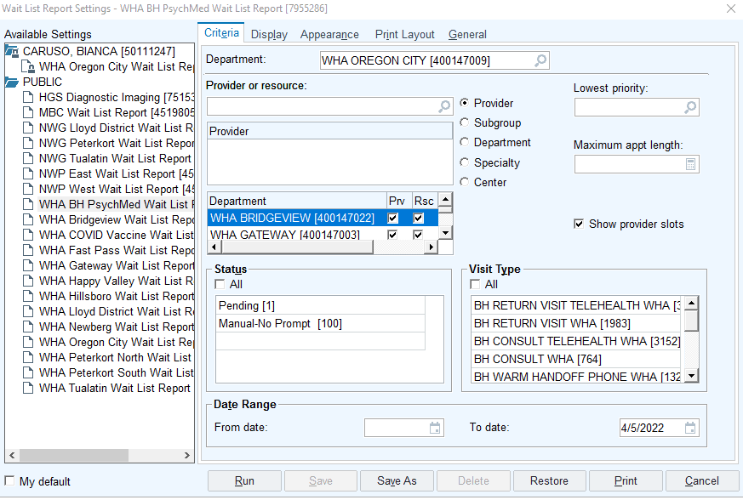
  - BH PSR clicks “start” on the top left of the wait list, so that the patients who have been on the wait list the longest are now at the top of the wait list
  - BH PSR chooses the first patient on the wait list, right clicks “appt desk” to go into the patient's account
  - BH PSR makes first initial outreach to patient offering to schedule a BH consult
    - Scripting if the patient answers to 1st outreach attempt and accepts BH care from the wait list:
“Hello, this is [name] from Women’s Health Care Associates calling to inform you that you have reached the top of the behavioral health wait list. Were you still interested in scheduling an appointment with one of our licensed therapists?”
  - BH PSR makes an appointment using the visit type “BH Consult Telehealth”
  - BH PSR highlights and chooses the only BH providers who have availability on their caseloads to take on a new patient (go to BH Caseload and Referral Workflow spreadsheet on the P Drive)
    - How to find caseload spread sheet: This PC -> WHA flash drive -> Behaviorist -> Public -> Workflows -> Caseloads -> BH Caseload and Referral Workflow excel spreadsheet
    - Reminder: the yellow number is the number of openings/patients a provider has available to take on – in this case the provider can take on 9 more new patients
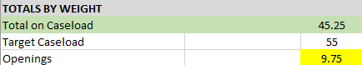
  - BH PSR then unclicks “auto search” and starts looking throughout the BH providers schedules manually as their schedules are blocked for consults when using auto search
  - BH PSR schedules the patient in the next available green opening and not on a BH providers oncall/triage day
    - Reminder: a BH provider can only see 2 BH consults per day, go to the next available day where a provider has 1 or less BH consults on their schedule
    - For example: Below, Torrie is on call with 2 triage openings in the afternoon, but Monica and Rebecca are not on call with green openings and do not have any consults scheduled therefore you would choose to schedule the patient with either Monica or Rebecca, not Torrie
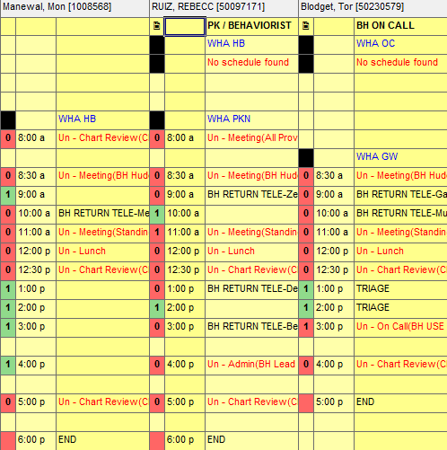
  - BH PSR reminds the patient that this is a 60-minute video session with the therapist
  - BH PSR removes the patient from the wait list once scheduled for a BH Consult
    - Appointment notes = Video Visit: pt aware of txt message – BH intake scheduled from wait list, sent informed consent, added to caseload – ph# xxx-xxx-xxxx
  - BH PSR sends the patient the BH informed consent (dot phrase BINCONS) via myhealth or mail
    - Subject = Information Regarding Upcoming Visit [insert date of BH consult]
  - BH PSR adds patient to the BH providers caseload that the patient is scheduled with for the BH consult (go to BH Caseload and Referral Workflow spreadsheet on the P Drive)
  - If the patient answered at the 1st outreach attempt and declined BH care, you would remove the patient from the wait list and note in the referral shell and BH scheduling outreach phone encounter with the same information:
[today’s date] - patient reached the top of the behavioral health wait list today and an outreach was made to the patient, the patient answered and was offered a BH consult but patient declined BH services because [insert reason], patient is aware that she would need a new behavioral health referral from her WHA provider if she decided she would like to engage with the program in the future.
  - BH PSR accepts out of the referral and signs the BH scheduling outreach phone encounter

  - Scripting if the patient doesn’t answer 1st outreach attempt to schedule BH consult from the wait list:
“Hello, this is [name] calling from Women’s Health Care Associates to inform you that you have reached the top of the behavioral health wait list. If you are still interested in scheduling an appointment with one of our licensed therapists or if you choose to decline BH care please give our office a call back at 503-657-1071, thank you”
- BH PSR updates the wait list noting that an outreach attempt was made to the patient and that a myhealth message was sent
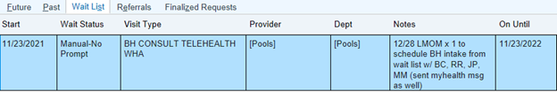
- BH PSR sends the patient a myhealth message (dot phrase WHABHWAITLIST1STCALL) for 1st outreach attempt:
“Dear [patient], We attempted to reach you by phone today to schedule a Behavorial Health visit. We want to inform you that you have reached the top of the behavioral health wait list and now have the opportunity to schedule an appointment with one of our licensed therapists at WHA. The appointment would be a 60-minute video session over your smart phone and you would need to be in a quiet, private place to complete your visit.
Please respond to this myhealth message with what days and times work best for you or give our office a call at 503-657-1071 to let us know if you would like to move forward with schedule or if you are declining to schedule at this time.
We do ask that you please respond via reply to this message or phone call as soon as possible. We will make a second and final attempt to reach you within the next week, if you do not respond to either attempts you will be removed from our wait list, and you will need a new referral to enter behavioral health care at WHA. Thank you, Bianca - WHA scheduling Ph: 503- 657-1071"
- BH PSR accepts out of the patients account and moves onto the next patient on the wait list to call

  - Scripting if the patient doesn’t answer 2nd outreach attempt to schedule BH consult from the wait list:
“Hello, this is [name] calling from Women’s Health Care Associates to inform you that you have reached the top of the behavioral health wait list. If you are still interested in scheduling an appointment with one of our licensed therapists or if you choose to decline BH care please give our office a call back at 503-657-1071, If we do not hear back from you within one week then we will be removing you from the wait list. thank you”
- BH PSR updates the wait list noting that an outreach was made to the patient and that a myhealth message was sent
- BH PSR sends the patient a 2nd myhealth message (dot phrase WHABHWAITLIST1STCALL) for 2nd outreach attempt:
“Dear [patient], We have made a second and final attempt to reach you today by phone to schedule a Behavioral Health visit. We want to inform you that you have reached the top of the behavioral health wait list and now have the opportunity to schedule an appointment with one of our licensed therapists at WHA. Please respond to this MyHealth Message with what dates and times may work for you or call me at 503-657-1071 to schedule a visit or to decline service at this time. Thank you, Bianca - WHA Scheduling”
- BH PSR accepts out of the patients account and moves onto the next patient on the wait list to call
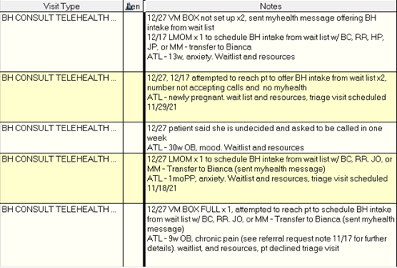
- BH PSR will attempt to reach a patient 2x to schedule a BH consult from the wait list, after the 2nd outreach attempt the patient will have one more week to give WHA a call back, if we do not hear back from the patient 1 week after the 2nd outreach call, then the patient will be removed from the wait list and will need a new referral from their WHA provider

For example above is a photo of the patients who are next on the wait list and have not responded to outreach attempts, they will get removed from the wait list with a note in the referral shell and the BH scheduling outreach phone note:
[today’s date] - patient reached the top of the behavioral health wait list today and an outreach was made to the patient, the patient answered and was offered a BH consult but patient declined BH services because [insert reason], patient is aware that she would need a new behavioral health referral from her WHA provider if she decided she would like to engage with the program in the future.

Workflow A4: Triage Consults
- Triage consults were designed to address urgent patient needs when demand for therapy exceeds capacity. Triage consults are designed for OB and PP patients eligible for Health and Behavior billing, which does not require a diagnostic interview, allowing the therapist to focus on immediate stabilization, decision-making or safety and a brief (usually 1-3 visits) episode of care.
- Examples of triage-eligible issues are in the decision grid in this manual.
- Triage consults are not added to caseloads.
- In the scenario that there are caseload openings within 5 days, patients should be added to a caseload rather than having a triage visit scheduled.
- Therapist completing triage appt may recommend prioritizing patients for caseload by sending a staff message to the WHA Patient Services Behavioral Health Pool. Therapist seeing patient for triage is responsible for assessing level of need and making community referrals such as home visiting as these should be made as soon as possible. Referral to PMHNP is also encouraged at this point.
- Therapist completing triage appt will always need to send a message to the WHA Patient Services Behavioral Health Pool with an update stating:
  - Patient should remain on waitlist for therapy
  - Patient should be removed from waitlist for therapy, their needs have been met
  - Patient should be prioritized for therapy within x time frame
- Triage blocks are available daily on the BHC on call schedule and any late cancels within the next 48 hours are also available to use for triage.
- If a patient no shows their one-time triage visit, they will not get a call from the BH PSR to reschedule. The patient will remain on the wait list and will be called to schedule when they get to the top of the wait list to schedule for ongoing therapy with a BHC.
- If the patient calls in on her own asking to reschedule her missed one-time triage visit, okay to reschedule.
  - Can offer any “triage” opening within the next 10 days or any green “open” spots within the next 48 hours with any BH provider

BH PSR workflow for scheduling a non-urgent vs urgent one-triage visit:
- BH PSR makes initial outreach to patient from BH referral that qualifies for a one-time triage visit
- BHCC will indicate in the referral shell whether the patient needs a “non-urgent” triage, or an “urgent” triage based on the patients' needs
  - Non-urgent triage= can be scheduled in the next available opening or within 10 business days
  - Urgent triage= needs to be scheduled within 2-3 business days
- BH PSR checks the schedule for openings, If the schedule does not allow for an urgent triage visit, then reach out to the BHCC to update her with this information
- BH PSR plan of action is to schedule the urgent triage patient for the next soonest available opening with any BH provider in any green open slot or triage slot (BH provider cannot see more than 2 triage patients per day), even if it is scheduled out further than 2-3 business days
- BH PSR will bring up this patient as priority during the BH huddle the next morning to discuss plan of care
- BH PSR and BHCC will keep a close eye on ALL BH providers schedules checking to see if any cancellations become available sooner
- If a sooner visit becomes available, BH PSR will reach back out to the patient and offer the sooner date/time
- If a sooner visit does not become available, the BHCC will conduct a warm hand off to the patient IF she expressed at initial time of call that she needs to talk with someone sooner

Workflow A5: Scheduling Patients for a BH Consult/adding patients to BHC caseloads
BH PSR identifies an opening on a BH providers caseload and initiates caseload addition process: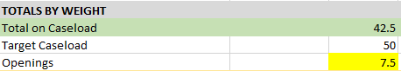
- The highlighted yellow number is the # of “available weight” of a patient a BH provider can take on to fill their target caseload
- To calculate actual openings, subtract the yellow openings from the number of pending scheduled patients in the bottom section of a BH providers caseload
- Never add more patients to the pending section than there are available openings (yellow number above)
- If the patient is reached, BH PSR schedules patient for a BH consult within the next 5 weeks and then adds patient to BH providers caseload list at starting weight “0”.
  - How to find caseload spread sheet: This PC -> WHA flash drive -> Behaviorist -> Public -> Workflows -> Caseloads -> BH Caseload and Referral Workflow excel spreadsheet
  - BH PSR adds patient to the correct BH providers caseload
      - BC = Barbara (Bobbi) Coiner
      - BMR = Rebecca (Becky) Ruiz
      - JP = Joan Pugh
      - KXD = Kimberley Dockery
      - KS = Katie Snow
      - TB = Torrie Blodget
      - HXP = Heather Phillips
      - IRC = Ivy Cardillo
      - MM = Monica Manewal
  - BH PSR fills in all information for the “scheduling outreach in process” box for the patient that was added to the spreadsheet
  - How to find out total # of visits in episode: go to patients' chart -> chart review -> filters -> episode -> WHA Behavioral Health
    - If there isn’t a WHA BH tab after clicking episodes, that means the total # of visits in episode is 0
    - If there is a WHA BH tab after clicking episodes, you would enter the number under count for the total # of visits in episode and mark an “X” under multiple episodes of care
- BH PSR makes sure not to add more patients to caseload than there are available openings
- BH PSR provides informed consent (BHINFCONS) to the patient via myhealth or letter, reminding the patient to review this information before their first BH visit
  - Appointment notes for a patient who was scheduled for a BH consult: “VIDEO Visit: pt aware of txt message – BH intake, added to caseload, sent informed consent – ph# xxx-xxxx"
- If the patient is not reached, BH PSR leaves message and then defers the referral out for one week
- 1st referral outreach attempt voicemail scripting for BH intake:
“Hello, I am calling from Women’s Health Care Associates regarding a behavioral health referral received from your WHA provider. We would like to offer you an intake with one of our therapists, if you are interested in scheduling, please give our office a call back to schedule at 503-657-1071, thank you”
- If the patient does not call back within one week, BH PSR makes a second referral outreach call
- 2nd referral outreach attempt voicemail scripting for BH intake:
“Hello, I am calling from Women’s Health Care Associates regarding a behavioral health referral received from your WHA provider. This is our second attempt to reach you and we would like to offer you an intake with one of our therapists, if you are interested in scheduling, please give our office a call back to schedule at 503-657-1071, if we do not hear back from you within one week then we will be closing out the referral, thank you”
  - Send a myhealth message to the patient after 2nd referral outreach attempt if the patient is not reached requesting a call back, then defer the referral out for another week
  - If patient calls back within one week of last outreach attempt, BH PSR schedules patient and provides informed consent (BHINFCONS) and updates “BH scheduling Outreach” phone encounter
  - If patient does not call back within one week after the second call, BH PSR closes the referral and updates the “BH scheduling Outreach” phone encounter
- If the patient does not call back 30 days after the first initial referral outreach, the patient will need a new BH referral from their WHA provider and will need to go through the referral review process again
- When BHC sees pt for consult, BHC sends staff message to WHA Behavioral Health Patient Services pool indicating the patient should be added to caseload and the weight.

Workflow A6: Adding Medication Assisted Treatment/MAT patients to caseloads
Referral into MAT at WHA is a separate referral process outside of the typical BH referral process. Referral into MAT occurs by medical providers as a referral to NWP Moderate Risk Clinic and is reviewed by the Clinical Care Coordinator (CCC) RN at NWP. The referral process to MAT is detailed outside of this document.
- As a part of MAT, patients are seen by a MAT BHC for a MAT consult to assess level of care needs for addiction treatment and obtain detailed recommendations for their care. This appointment is typically scheduled by a MAT RN or NWP Back office navigator as part of the MAT workflows. The MAT BHC is typically involved in helping find times for this patient to be seen.
- MAT patients should be scheduled using the BH Telehealth Triage visit type, the WHABHMATCONSULT documentation template and health and behavior billing (96156 paired with 099.34...).
- Once the MAT BHC has seen the MAT patient, the MAT BHC sends a staff message to the WHA Behavioral Health Patient Services Pool indicating the patient should be added to their MAT caseload. The MAT BHC has a designated section on their BH Caseload specifically for MAT patients. These patients have a caseload weight of 0, as MAT BHCs have a reduced caseload and blocked time on their schedules to support patients enrolled in MAT.
- Additionally, the MAT BHC has the responsibility of communicating out their recommendations to the MAT MD, RNs and those involved in scheduling as well as updating the chart to reflect level of care and case management task completion.
- Typically, MAT BHC will see patients on their MAT caseload 1-2 times per month using the BH Telehealth Triage visit type and the BHMATFUP documentation template. MAT patients typically continue in BHC care until they are 6 weeks postpartum or beyond and they have transitioned their MAT prescription to another clinic. At this point, the MAT BHC is responsible for notifying the BH PSR to remove the patient from their MAT caseload.
- The MAT BHC or another provider may also refer patient for an episode of psychotherapy with a WHA BHC. This is considered a separate service, not a duplication.

Workflow A7: Behavioral Health Caseload
When BH PSR calls patients from WL to offer spot on therapist caseload, patient is added to caseload spreadsheet with weight of “0”. BH PSR does not call to offer more appointments on a caseload than spots available on caseload.
- The BH PSR adds the following information to the caseload upon scheduled consult:
  - Patient Name, alphabetical by last name
  - MRN
  - Weight
  - PT Type: OB w/EDD, PP w/DD, GYN, or GYNMED
  - Referral Date
  - Referral Reason including patient type at referral (OB, PP, or GYN) as well as affiliated mental health reason for referral (perinatal mood, anxiety, SAB, etc.)
    - Ex. OB – Perinatal Mood; GYN – Anxiety, PP – SAB
  - PMHNP Engagement (this is often N/A at time patient is entering BH)
  - Multiple Episodes of Care – Include ‘x’ if so and leave blank if N/A
  - Date of Scheduled Consult under ‘# of F/U Scheduled’ Column
- BHC sees new consult and sends staff message from patient chart to WHA Patient Services Behavioral Health Pool indicating if patient should be added to caseload and at what weight. These are the options to write in staff messages regarding patient weight:
  - Patient no-showed, follow no show workflow
  - Add patient to caseload at 1.0 (if plan is to see x2-3 monthly until status change around visit 10-15). This will typically be the weight of any new patients.
  - Add patient to caseload at .5 (if plan is to see monthly). This will typically be a weight change as care winds down and patient is able to practice skills more independently.
  - Add patient to caseload at .25 (if plan is to see less than monthly, every 2-3 months). This will typically be a weight change as care reaches the maintenance phase.
  - Move patient to weight 0 until (list date up to 6 mos from current date that pt can return for a booster session). After that date patient will be removed from caseload.
- BHC is responsible for keeping caseload updated through the above-outlined staff message process as well as regular review of the caseload itself to catch anyone who hasn’t rescheduled.
- Caseloads are also reviewed regularly by BH PSR, BHCC and BH leads and director to facilitate ongoing awareness of program capacity.
- Each BHC has set “cap” on their caseload based on FTE and role. This is reflected on the caseload spreadsheet. However, if schedules are not full in spite of a full caseload, additional patients may be added to caseload to facilitate full schedules.
- Caseloads are reviewed quarterly by leadership/admin team and individual clinicians should be reviewing weekly and updating as patient statuses change.

Workflow A8: Behavioral Health Consult No Show Workflow
- BH PSR will send a text message every day at 4:00pm to each BH provider that is on the schedule for the day. The text message should say:
“Good afternoon, this is your daily check in to report your telehealth no shows for today 😊 - [insert your name] OC PSR”
- BH PSR will then mark all patients that the BH clinician indicated “no showed” for a telehealth visit that day
  - How to “No Show” a visit: Right click on the appointment on the DAR, click “No show”, and then click “No Show Only” and the appointment status will be marked as no show
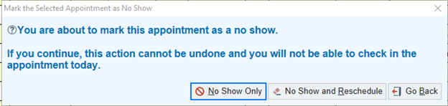
- If indicated in the BH providers text message to call patient and offer to reschedule their missed BH consult, BH PSR will then make outreach to patient offering to reschedule
  - If a patient no shows a BH consult x1, it's okay to reschedule in the next available opening with the same BH provider that the patient was originally scheduled with
    - Cannot schedule or reschedule a BH consult on a BH providers “on-call/triage” day, must be in a green open slot
    - Cannot schedule or reschedule a BH consult on a BH providers schedule that already has 2 BH consults scheduled that day
    - A BH provider can only see 2 BH consults per day
  - If the patient answers the first outreach attempt to reschedule:
“Hello, this is [insert name] from Women’s Health Care Associates, we are reaching out to you due to your missed behavioral health appointment with our office. We would like to reschedule this visit with your provider so we can see you for your needs. As a reminder, we request that you give us 24-hour notice for cancellations so that we may offer the appointment time to another patient in need of care. If you were to no show a second time for this visit, you would need a new behavioral health referral from your provider to receive behavioral health care”
- BH PSR reschedules the patient accordingly for their missed BH consult with the same provider they were originally scheduled with
- BH PSR updates the BH scheduling outreach phone encounter with the new date and time for the rescheduled BH consult
- BH PSR then opens the caseload spreadsheet and updates the new date for the rescheduled BH consult on the corresponding BH providers caseload
  - If the patient doesn’t answer the first outreach attempt, detailed voicemail scripting:
“Hello, this is [insert name] from Women’s Health Care Associates, we are reaching out to you due to your missed behavioral health appointment with our office. We would like to reschedule this visit with your provider so we can see you for your needs. As a reminder, we request that you give us 24-hour notice for cancellations so that we may offer the appointment time to another patient in need of care. Please give us a call back at 503-657-1071 to get rescheduled. If you were to no show a second time, you will need a new behavioral health referral from your provider to engage with our BH program again. Thank you”
  - If the patient doesn’t answer the first outreach attempt, generic non-detailed voicemail scripting:
“Hello, this is your doctor’s office reaching out regarding your missed appointment, please give us a call at 503-657-1071 to reschedule. Thank you”
- BH PSR then sends a staff message to the PS BH pool to ensure that the patient will get another phone call offering to reschedule the missed appointment. The staff message should note: “offer to r/s missed BH consult with [insert BH provider name]” and postpones the message for one week
- Once the staff message reappears in the pool after one week, BH PSR makes a second outreach call to patient
  - If the patient answers the second outreach call, reschedule BH consult accordingly with the same BH provider patient was originally scheduled with following the scheduling guidelines under step #3
  - If the patient doesn’t answer the second outreach call, a staff message is sent to the BH provider that the patient was scheduled with as a FYI and then done the original staff message
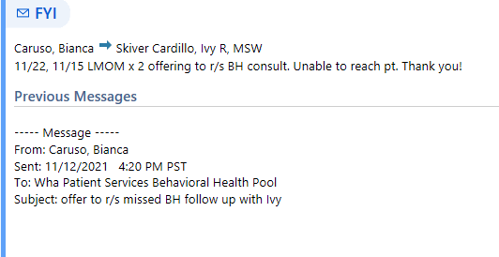
- If a patient no shows a BH consult x2, the patient will not be called to reschedule. The patient will then need a new BH referral from their WHA provider and will need to go through the referral review and/or wait list process again
- BH PSR sends No Show letter (LEAP WHA NO SHOW –1st NO SHOW LETTER) to patient’s MyHealth portal or mail to patients address
- BH PSR provides informed consent (BHINFCONS) to any scheduled patient for a BH consult via myhealth or mail and verbally informs the patient:
“I will be sending you a general overview of behavioral health to your [myhealth portal] or [mail you a copy to your address] we just ask that you review this information before your first initial visit with the therapist, thank you”

Workflow A9: Triage Visit No Show Workflow
- If a patient no shows a BH one time triage visit, BH PSR does not reach out to patient to reschedule unless a BHC specifically requests that outreach should be made
- Update “BH scheduling Outreach” phone encounter that patient no showed triage visit but will remain on the wait list
- If a patient calls back with any urgent needs, they will be considered for an additional triage visit
- Leave patient on BH waitlist unless otherwise instructed by a BHC

Workflow A10: Addressing urgent mental health needs for patients NOT eligible for triage/BH care
Any WHA patient may receive a referral to behavioral health. The referral is the best communication tool to use to communicate patient needs with the behavioral health team.
- For needs deemed urgent, referrals can be marked “urgent”. These referrals will be reviewed immediately if they come in during the workday prior to 4 pm. They will be reviewed by 9 am on the next working day if they come in after 4 pm.
- For urgent safety needs such as active suicidal ideation, the behavioral health referral is not the best option. The crisis line for the county the patient is in or 911 should be used for needs that are this urgent. WHA does not have a crisis line and cannot respond in the manner expected of a crisis line. Area crisis resources can be found in Epic in the .WHAMHREFER dot phrase or .BHCRISIS for a shorter list.
- For those needs that are appropriate for a behavioral health referral, patients not eligible for internal behavioral health services will be provided resources in response to the needs indicated in the referral. These resources will be entered into the patient’s chart by the Behavioral Health Care Coordinator upon referral review and will be provided via phone call and myhealth message by the Behavioral Health PSR.

Section B: Established Therapy Patient Workflows

Workflow B1: Model of therapeutic care
- Patients are referred to WHA behavioral health to address an issue that arises while receiving care at WHA.
- The demand for mental health care is high and finding a balance between providing quality care that meets patient needs and maintaining access is always challenging.
- WHA behavioral health therapy offers an episode of therapy that typically involves 10-15 visits that occur 2-3x monthly and that decrease in frequency toward the end of care.
- Patients who begin care during pregnancy can expect to be able access therapy at WHA through the early postpartum period (around 3-4 months postpartum) even if this increases the total number of visits beyond 15.
- Many referral issues are chronic issues with episodic worsening. It may not be realistic to expect patients to come to full resolution of symptoms but it is often realistic to expect that new skill acquisition can occur during an episode of care.
- At the conclusion of therapy at WHA patients can expect to receive support accessing ongoing therapy outside of WHA including high quality referrals.
- Patients who do not wish to engage in therapy at WHA will receive a high-quality referral list and additional support accessing care if needed.
- It is important for BHCs to balance direct communication with patients regarding what to expect from care with the many tasks of initiating therapy including engagement, assessment, and treatment planning.
- Interpersonal Psychotherapy and Cognitive Behavioral Therapy have the strongest evidence base for treating most mental health issues in the perinatal period and BHCs will receive training and consultation to utilize the most effective methods of treatment.
- Patients are provided with an Informed Consent statement upon scheduling their first therapy appointment. This informed consent spells out the specifics of our care environment and provides additional resources should the patient wish not to engage in the specified model of care for any reason.

Workflow B2: Scheduling follow up visits
- As a part of the initial assessment/consult, the BHC recommends the cadence of follow up visits to the patient (usually approx every 2 weeks unless high acuity issues require more frequency on temporary basis). The recommended cadence and total number of recommended visits are documented in the treatment plan.
- After completing the consultation, the BHC schedules at least one follow up visit themselves, to insure continuity of care which is challenged by telehealth and not being able to schedule after leaving BHC office at a clinic.
- The BHC sends a staff message regarding patient “weight” to the WHA Patient Services Behavioral Health Pool. See section A4 #5 for detailed instructions.
- After completing the consultation and scheduling at least one follow up, the BHC notifies the patient that they will receive a call to schedule additional follow up visits from our scheduling team. We recommend they schedule out 3-4 appointments to reserve a desirable time and to be sure they are seen with the recommended frequency. The patient may also call the office to schedule, enter scheduling instructions into AVS using .BHSCHEDULING .
- The BHC enters scheduling instructions into the Follow-up section in the Wrap up activity in their note:
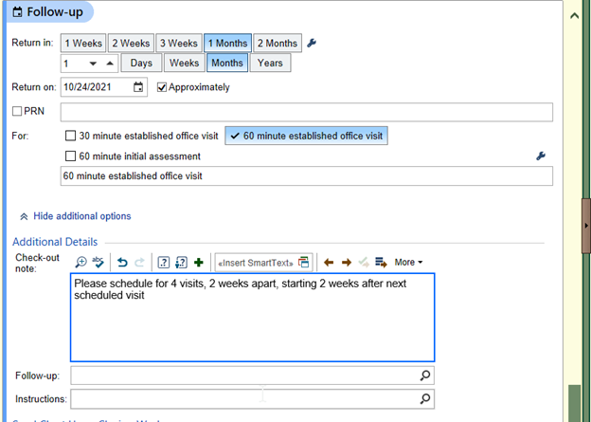
- BH PSR copies the follow up disposition notes when checking out a BH patient from their completed visit and pastes the notes into a staff message
- BH PSR then sends that message to the “Patient Services Behavioral Health” pool
- BH PSR does this for each patient that was scheduled for that day to ensure each check out note is received and documented
- BH PSR reaches out to a BH provider via staff message if there aren’t any check out notes for a patient who completed a BH consultation - could have been mistakenly missed
- BH PSR then goes to the staff messages in the PS BH pool once check out is complete and starts making outreach calls to each patient that had a check out note
- BH PSR makes first outreach call to patient
  - If the patient answers to first outreach, BH PSR schedules patient accordingly to check out instructions and then “done” the staff message so that it is no longer in the pool
  - If the patient doesn’t answer to first outreach, BH PSR then documents a note on the patients last visit with BH provider “Date, LMOM x 1, to schedule [insert BH providers check out notes]” so that any scheduler who gets the patient calling in can see why an outreach was made/what is needed to schedule
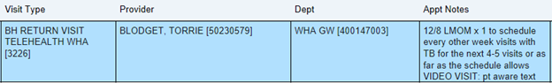
  - BH PSR then goes back to the pool and clicks “comment” on the staff message and notes “Date, LMOM x1” on the staff message for the patient who did not answer and postpones the staff message for one week
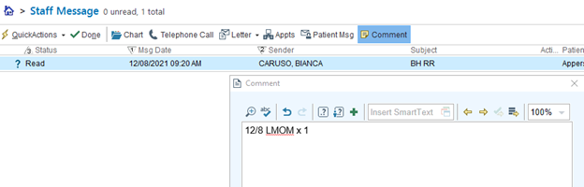
- BH PSR makes a second outreach call to patient once the staff message reappears in the pool after one week
  - If the patient answers to second outreach, BH PSR schedules patient accordingly to check out instructions and then “done” the staff message so that it is no longer in the pool
  - If the patient doesn’t answer to second outreach, BH PSR forwards the message to patient BH provider as a FYI as shown below
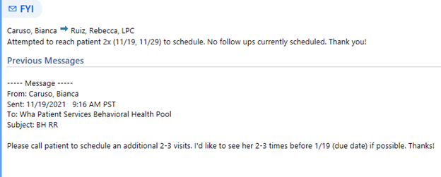
- Regular review of caseloads helps with catching patients who have cancelled and not rescheduled. For these cases, outreach by the BHC to the patient is recommended in order to understand if they wish to continue therapy. For those who do not or who do not respond, send staff message to WHA Patient Services Behavioral Health Pool, moving weight to 0 until x date.
- Patients who do not reschedule or respond to outreach will be able to call back in to schedule for up to 6 months without a new referral

Workflow B3: Addressing urgent needs for established therapy patients or patients on WL
If a patient who is currently established for therapy or on the WL calls in indicating they have an urgent need, a phone note documenting the need should be completed and routed to the WHA Behavioral Health Patient Services Pool
- The note will be reviewed by the BH PSR
- BH PSR will look at following options for patients:
  - Reach out to the therapist if they are assigned a therapist who is working that day for input if needed
  - Schedule patient with their therapist if appt available in reasonable timeframe
  - Offer triage visit if available with any therapist on the team
  - If options A-3 not available consult with director or lead for additional options.
  - For patients on waitlist its ok to schedule a triage visit without consulting therapists
- Patients expressing safety issues that cannot wait (if no BH team member or Advice RN immediately available) should be warm transferred to the county crisis line for their county (use phone system to conference patient to crisis line)
Mental Health Crisis Lines: Use crisis line for the county you are IN when needing help
  - Clackamas County: 503-655-8585 (24/7) or walk in 11211 SE 82nd Ave., Suite O, Happy Valley M-F 9-8, S&S 10-7
  - Multnomah County: 800-716-9769 (24/7) or walk in at 4212 SE Division St, Portland 7 am - 10:30 pm, seven days a week
  - Washington County: 503-291-9111 (24/7) or walk in at 5240 Elam Young Pkwy #100, Hillsboro 9 am-830 pm seven days a week
  - Yamhill County: 1-844-842-8200 (24/7, directs to Lines for Life after business hours) or walk in 627 NE Evans St. McMinnville (503) 434-7523 M-F 8:30-5
  - Columbia County: (503) 782-4499 (24/7) or walk in Walk-In 58646 McNulty WaySt Helens OR 97051 Monday and Tuesday 1pm-3pmThursday and Friday 9am-11am

Workflow B4: No show workflow for return visits
BH PSR will send a text message every day at 4:00pm to each BH provider that is on the schedule for the day. The text message should say:
- “Good afternoon, this is your daily check in to report your telehealth no shows for today 😊 - [insert your name] OC PSR”
- BH PSR will then mark all patients that the BH clinician indicated “no showed” for a telehealth visit that day
  - How to “No Show” a visit: Right click on the appointment on the DAR, click “No show”, and then click “No Show Only” and the appointment status will be marked as no show
- If indicated in the BH providers text message to call patient and offer to reschedule their missed BH return visit, BH PSR will then make outreach to patient offering to reschedule
  - If a patient no shows a BH return visit x1, okay to reschedule in the next available opening with the same BH provider that the patient was originally scheduled with
- If the patient answers the first outreach attempt:
“Hello, this is [insert name] from Women’s Health Care Associates, we are reaching out to you due to your missed behavioral health appointment with our office. We would like to reschedule this visit with your provider so we can see you for your needs. As a reminder, we request that you give us 24-hour notice for cancellations so that we may offer the appointment time to another patient in need of care”.
- BH PSR reschedules the patient accordingly for their missed BH return visit with the same provider they were originally scheduled with
- If the patient doesn’t answer the first outreach attempt, detailed voicemail scripting:
“Hello, this is [insert name] from Women’s Health Care Associates, we are reaching out to you due to your missed behavioral health appointment with our office. We would like to reschedule this visit with your provider so we can see you for your needs. As a reminder, we request that you give us 24-hour notice for cancellations so that we may offer the appointment time to another patient in need of care. Please give us a call back at 503-657-1071 to get rescheduled, Thank you”
- If the patient doesn’t answer the first outreach attempt, generic non-detailed voicemail scripting:
“Hello, this is your doctor’s office reaching out regarding your missed appointment, please give us a call at 503-657-1071 to reschedule. Thank you”
- BH PSR then sends a staff message to the PS BH pool to ensure that the patient will get another phone call offering to reschedule the missed BH return appointment. The staff message should note: “offer to r/s missed BH return visit with [insert BH provider name]” and postpones the message for one week
- Once the staff message reappears in the pool after one week, BH PSR makes a second outreach call to patient
  - If the patient answers the second outreach call, reschedule BH return visit accordingly with the same BH provider patient was originally scheduled with
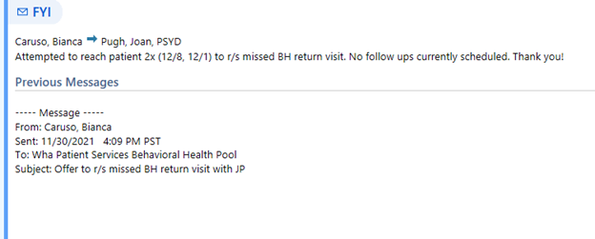
  - If the patient doesn’t answer the second outreach call, a staff message is sent to the BH provider that the patient was scheduled with as a FYI and then done the original staff message

- If a patient no shows a BH return visit x2, our standard is to continue care. It will be up to the clinician to determine when to discontinue seeing the patient, otherwise we will continue to follow the same no-show workflow no matter how many times a patient no shows their BH return visit
  - The BH provider may reach out to the patient directly who has been a recurring no show and cancel their next upcoming visit so that they can offer it to another patient
- BH PSR sends No Show letter (LEAP WHA NO SHOW –1st NO SHOW LETTER) to patient’s MyHealth portal or mail to patients address

Workflow B5: BH FMLA workflow
The intention of this workflow is to ensure that all BH FMLA paperwork is managed within the BH team, and not by the general WHA clinical teams. The BH team will only be completing FMLA paperwork for patients who are actively engaged in therapy at WHA and are accounted for on a provider case load. This is not a large volume of work. There are generally 5-6 in a six-month period.
- Site receives BH FMLA request from patient (patient may present at the clinic with FMLA paperwork, or patient may call in requesting information about FMLA process)
  - If patient is calling in patient should be transferred to BH PSR (Bianca Caruso)
  - If patient presents at clinic with FMLA paperwork collect ROI and start FMLA phone note. Rout FMLA phone note to WHA Patient Services Behavioral Health Pool, and fax paperwork to OC PSR Fax @ 503.855.1580
- BH PSR reviews FMLA paperwork request
  - Verifies patient is an active BH caseload patient
  - Determines if patient has an upcoming BH appointment
  - Coordinate with Behavioral Health Care Coordinator to determine if patient’s recent appointments have any documentation regarding FMLA
    - If patient has no recent documentation from therapist regarding FMLA paperwork patient will need to have an appointment with their BHC to discuss.
- BH PSR will contact patient and discuss FMLA process with them.
  - Will schedule an appointment if needed (can use triage if necessary)
  - If patient has upcoming appointment will tell patient to discuss FMLA need at upcoming appointment
  - Document discussion in telephone encounter and input appropriate dot phrase (.whaBHleaverequest1) route to BH pool associated with the appropriate BHC
- BH PSR will locate FMLA paperwork that was sent via fax and complete the non-clinical portions of the paperwork (name, patient ID, etc.), and place in BHCC In Basket in OC BH office
- BHC will complete information requested in the .whaBHleaverequest1 dot phrase and route back to OC BH Pool
- BHCC will check in box for semi complete FMLA paperwork.
  - Review OC BH Pool and complete FMLA paperwork as intended based on information in the .whaBHleaverequest1 dot phrase
  - BHCC will communicate with BH PSR when FMLA paperwork is complete
- BH PSR will follow up with patient once FMLA paperwork is complete and has been sent to the appropriate place.

Workflow B6: Caseload Review
- A quarterly review (January, April, July, and October) is conducted in which the BHCC reviews the caseload for each BHC in order to account for accuracy, consistent engagement by BHCs, and to track program averages.
  - The review seeks to confirm that all patients on a BHCs caseload are being consistently accounted for to be sure open availabilities are being noted and filled. This is reflected in the reviews goal of tracking the date patient was last seen as well as the number of follow-up visits scheduled. The number of visits in the episode is identified in order to understand the nature of episodic care within the program and monitor participation of a 10-15 visit average.
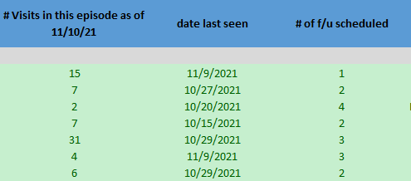
  - The referral reasons (OB, PP, GYN), PMHNP engagement, and patients with multiple episodes of care are totaled on each caseload in order to offer insight into program development. For example, a caseload may have 7 patients out of 40 who are engaged with the PMHNP, or a caseload may have 35 postpartum patients and 5 OB patients at the time of referral. The number of visits in this episode are totaled with the ranges of 0-5, 6-10, 11-15, and 15+ to indicate the average episode of care for the provider and identify patient outliers who are over/under the typical episode of care.
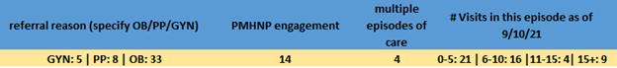
- The BHCC uses information provided in generated reports to confirm appropriate tracking on the caseload. The information on the reports is cross referenced with the information on the caseload.
  - The number of follow-up visits, number of visits in each episode as well as date last seen are updated using information from the generated reports.
  - Patients who are scheduled for at least one follow-up appointment are highlighted in green to indicate they have been adequately accounted for on the caseload.
  - Patients who have no follow-ups scheduled, but are listed in the assessment, middle, conclusion, or maintenance phase are highlighted in red. This is to indicate the BHC must review if the patient requires scheduling of follow ups or needs to be moved to a weigh of ‘0’ on their caseload.
  - Patients who appear on the report but not on the caseload are indicated for review by listing patient name, MRN, and upcoming encounter date on the bottom of the caseload spreadsheet to be addressed during quarterly meetings.
  - At times it will be necessary for the BHCC to confirm information by reviewing the patient's chart in EPIC.
  - Patients who are on the caseload as ‘Closure/PRN’ are reviewed. All patients whose date last seen was six months prior to the date of review are removed from the caseload.
- The Director of BH, BHCC, and BH PSR meet upon the completion of the quarterly case review in order to discuss the program totals, issues with tracking that have arisen, and any glaring concerns regarding the caseload processes.
- Quarterly meetings are conducted by the Director of Behavioral Health with each BHC in which caseload engagement is discussed. Notable points of interest include:
  - Consistency of notifying BH PSR about weight of patients on caseload
  - Average number of visits within an episode of care and outliers
  - Maintaining full or nearly full caseload

Section C: Exit from therapy workflows

Workflow C1: Addressing closure with patients
It is a key therapeutic skill to normalize closure of the therapeutic relationship and communicate to patients that the goal of therapy is to enhance communication, self-advocacy, and positive self-regard to improve the quality and quantity of social connections, leading to improved functioning. There are many ways to normalize this and the most important is to consistently hold up a mirror for the patient to help them see their strengths and abilities and to communicate what we see in them that they may not. We strive to connect patients more strongly to natural support, not more strongly to therapy, although therapy may be a part of many patients’ long-term needs.
- Around session 10-12, patient insight and skill-acquisition are at peak if session engagement has been consistent, and the therapist has used evidence-based tools. At this time, it is appropriate to plan to decrease visits to once a month, letting patients know the circumstances in which it may make sense to call to request a sooner visit.
- Around session 12-15, if the patient has reduced visits to monthly, it is likely time to move to meeting in 2-3 months as a step toward closure. Closure typically means that the episode is ending, any needed care is transferred, and the patient knows they can call back in for a “booster” session up to 6 months from the date of closure.
- At times, closure occurs before a full episode of care occurs. This can occur because the patient drops out of care without telling us, needs a higher level of care or different care or for other reasons. Clearly documenting these occurrences whenever possible is essential and should occur in the assessment and plan under the relevant problem and be routed to the rest of the care team.

Workflow C2: Assessing and documenting functioning at closure, documenting closure plan
- It can be helpful to patients to see and understand in a concrete manner the ways in which they have made strides in their mental health. One highly recommended way to achieve this is to repeat any screening tools such as the EPDS, PHQ9 or GAD 7 among others, comparing individual items to identify change.
- Additionally, the treatment plan should be reviewed upon closure and the goal should be “completed” in the chart.
- Problem-based charting should reflect what was discussed regarding items 1 and 2 as well as documentation of the specific closure plan.
- Detailed information regarding referrals and case management related to referrals should be evident in problem-based charting and patient-facing information such as AVS and myhealth messages.
- Staff message indicating weight change to 0 until x date should be sent to WHA Patient Services Behavioral Health Pool. BH PSR changes weight on caseload.

Workflow C3: Circumstances in which re-entry to care is warranted, parameters
At times, patients may make a closure plan and then call back in to request an additional visit. Unless there are special instructions that are clear in the chart, the patient may schedule an additional visit up to 6 months after closure is planned.
- When BHC meets with patient for a return visit post-closure, the therapist’s role is to address patient concerns about closure and any additional needs that have come up. In most cases, this should be possible in 1-2 additional visits and should not require re-adding patient to a caseload unless an extenuating circumstance has arisen. These cases should be discussed with a team lead to determine best next steps.
- There may be patients who are unable to accept the need for closure. Consultation and discussion in supervision is recommended in these cases.

Workflow C4: Referrals and case management
- Receiving high quality referrals and support making connection to services is a key benefit of engagement in behavioral health services. Each BHC is responsible for providing case management to patients on their caseload and the case management activities should be clearly documented under the relevant problem in the patient’s chart in the appropriate encounter type.
- BHC’s should prioritize networking with community programs and providers and should bring up areas in which they would like to increase their knowledge to their lead and director.

Section D: Well-being assessment workflow

Workflow D1: Visit types that include completion of the WBA
The Well-Being Assessment (WBA) is a mental health, substance use and social determinants screening questionnaire administered electronically along with other medical questionnaires in association with the following visit types:
- New Patient Appointment (first time at WHA, coming in for a problem-focused visit)
- Well-woman Appointment
- Prenatal Intake
- Post-partum well-woman appointment (“8 week” appt)
When patients complete the WBA with answers that meet or exceed the set threshold or answer for each questionnaire, a “Best Practice” alert is generated and routed to appropriate pools. For behavioral health, alerts are routed to the “WHA Behaviorist (location) Pool”.

Workflow D2: WBA Questions that Generate Alerts
The following responses/questionnaires generate alerts:
Question or Questionnaire | Responses Generating Alerts to BH
How do you feel about being pregnant?  (OB WBA) | I have mixed feelings  I am unhappy about it
Do you plan to continue the pregnancy?  (OB WBA) | I am not sure  No
Do you have the social and emotional support you need for pregnancy and parenting?  (OB WBA) | I am not sure  No
Edinburgh Postnatal Depression Scale (EPDS)  (OB WBA) | Score of 15 or above
On EPDS:  The thought of harming myself has occurred to me  (OB WBA) | Hardly Ever  Sometimes  Yes, Quite often  Also alerts RN Advice pool
Patient Health Questionnaire-9 (PHQ-9)  (PP/Gyn WBA) | Score of 15 or above
On PHQ-9  Thoughts that you would be better off dead or hurting yourself in some way  (PP/Gyn WBA) | Several Days  More than half the days  Nearly Every Day  Also alerts RN Advice pool
Do you feel safe at home?  (Ob & PP/Gyn WBA) | No  Also alerts RN Advice pool
Does your current partner talk to you in ways that make you feel bad?  Does your current partner control where you go, who you talk to or how you spend money?  Has your current partner hurt or threatened you, or forced you to have sex?  (Ob & PP/Gyn WBA) | Sometimes  Yes
Have you used tobacco or nicotine in any form (cigarette, vaping)?  (Ob WBA) | Yes
How would you describe your use of tobacco products?  (PP/Gyn WBA) | Sometime smoker  Current every day smoker
In the past year, how many times have you had 4 or more drinks in one day?  (Ob & PP/Gyn WBA) | 2 or more
Have you had trouble stopping drug or alcohol use since finding out you are pregnant?  (Ob WBA) | Yes
Have you used marijuana for medical or recreational purposes since finding out you are pregnant?  (Ob WBA) | Yes
Have you taken a prescribed medication to help with pain since finding out you are pregnant?  (Ob WBA) | Yes
Have you used any street drugs or taken methadone during this pregnancy?  (Ob WBA) | Yes
In the past, have you had difficulties in your life due to alcohol or other drugs, including prescription medications?  (Ob WBA) | Yes
Does your partner have a problem with alcohol or other drug use?  Did any of your parents have a problem with alcohol or other drug use?  Do any of your friends have a problem with alcohol or other drug use?  (Ob WBA) | 2 or more yes answers
How often do you have a drink containing alcohol?  (PP/Gyn WBA) | 4 or more times per week
If 2-3 times per week or more triggers:  How many drinks containing alcohol do you have on a typical day when you are drinking?  (PP/Gyn WBA) | Any answer over 4
If 3 or 4 or more triggers:  How often do you have 5 or more drinks on one occasion:  (PP/Gyn WBA) | Any answer more than yearly
How many times in the past year have you used an illegal drug or used a prescription medication for non-medical reasons (because of the experience or feeling the drug caused)?  (PP/Gyn WBA) | 1 or more
Do you feel that you ought to cut down on your drinking or drug use?  Do people annoy you by criticizing your drinking or drug use?  Do you feel bad or guilty about your drinking or drug use?  Do you have a drink or use drugs first thing in the morning (eye-opener) to steady your nerves or get rid of a hangover?  (PP/Gyn WBA) | 2 or more Yes answers

Workflow D3: WBA Follow up Documentation
The WBA is a shared responsibility on the BH team, covered primarily by the triage BHC of the day, the lead BHC of the day, the BHCC and any BHCs with patient cancellations for the day. The lead and triage BHC are responsible for doing their best to clear the best practice alerts each day.
Below is the BHWBARESPONSEEXTENDED dot phrase that is available in Epic to guide decision-making. This dot phrase is updated when new information is determined relevant and the phrase in Epic should be viewed for the most updated information. The BHWBARESPONSE phrase is also available, it is much shorter and is designed for those already adept at responding to WBAs.
The clinician completing the WBA is responsible for documenting their decision regarding the WBA through one of the following:
- If response already documented by medical provider or RN: no action
- If outreach performed: Warm Handoff Phone
- If review completed but no outreach performed: case management encounter
.BHWBARESPONSEEXTENDED:
Well-Being Assessment: Behavioral Health Follow up
@PREFNAME@ completed the Well Being Assessment. They filled it out in conjunction with her appointment on (x date) with (x provider) and had a concerning response requiring follow up on the following areas: (list here or paste from WBA)
Based on the above I took the following action:
(delete unneeded verbiage below)
Document in "note" section and copy and paste completed documentation under relevant problem on problem list as well (adding problem if not on problem list). If no relevant problem, these codes may be helpful:
Z13.32 Encounter for screening for maternal depression
Z13.39 Encounter for screening examination for other mental health and behavioral disorders
There is no specific ICD-10-CM or CPT code for domestic, sexual and interpersonal violence screening, but code Z13. 89, Encounter for screening for other disorder
The ICD-10-CM diagnosis code that may be reported for alcohol screening is: Z13.89, Encounter for screening for other disorder
ALWAYS review chart for RN note and/or provider documented discussion prior to outreach.
If RN already started outreach, delete notification, no further action.
If provider documented their discussion of all relevent notifications and it was satisfactory including safety and referral resources, delete notification, no further action.
When multiple notifications, complete outreach associated with most urgent notification, providing additional resources based on other notifications.
Route documentation to patient's provider or most recent/upcoming provider who will see patient unless outcome not notable.
Elevated OB EPDS or Elevated PHQ9 at 8 week post partum visit with or without Suicidal Ideation:
x2 call that day plus 1 myhealth message or mailed letter if no myhealth with BHWBAOBPPOUTREACH resources (includes language encouraging them to call clinic to speak with advice or their provider regarding MH concern ). Full review to be completed and signed on same day.
Goal of call is connection to mental health care & safety assessment.
A. BH to enter BH referral if accepted by patient. In referral, indicate EPDS/PHQ9 score and document additional needs including if you recommend triage visit. Set expectation for pt to receive a call from PSR to offer appt or waitlist.
B. If unable to reach patient, LM encouraging pt to call back to speak with an advice nurse regarding their MH concern or speak with their medical provider at their next appt (basically wording of top of BHWHAOBPPOUTREACH phrase) and let them know you sent info via myhealth or mailed letter.
C. If you reach patient and enter BH referral, also document in BH referral if pt thinks they may want to be referred to PMHNP if there are indicators skilled psychiatric medication management would be appropriate such as bipolar disorder, hx PP psychosis, OCD or pt indicates a mental health medication they are on is not well managed or not effective. If pt already has a therapist they should not be put on waitlist for WHA behavioral health therapy but they could see WHA PMHNP if needed, be detailed about this in BH referral. BHCC will review and enter PMHNP referral if appropriate after additional review.
D. Complete CSSRS and document using appropriate BHCSSRS dot phrase whether they have expressed SI on questionnaire or not. If CSSRS positive, complete appropriate safety plan with patient, documenting and sharing with patient. Use BHSAFETYPLAN. Connect to emergency crisis resources or consult with a team lead as needed.
E. Copy & paste documentation from note under associated problem: Mental Disorder Affecting Pregnancy, Anxiety Affecting Pregnancy, Depression Affecting Pregnancy, Post partum Depression, Post partum anxiety (099.34) or relevant F code if on list. If no relevant problem from list may add Z13.32 Encounter for Screening for Maternal Depression.
Route documentation to patient's provider if it is clear who will be seeing them for care.
OB Tobacco:
x1 phone call plus myhealth or printed letter BHTOBACCOLETTER, sign encounter same day.
Goal of call is connection to tobacco cessation resources. Use BHTOBACCOLETTER dotphrase to be aware of resources
A. BH to enter BH referral if accepted. Indicate it is for OB tobacco cessation. If already entering referral for mental health add tobacco cessation language into same referral (no need for more than one).
B. Ask pt if they would like to discuss medications to support tobacco cessation with their OB provider. If they say yes, encourage them to discuss with medical provider AND document this in the problem overview ("pt interested in medication for tobacco cessation") under the tobacco cessation problem so it is visible to the next medical provider seeing them. If pt would like to be seen more urgently to discuss cessation with their medical provider, encourage them to call advice RN or start phone note with appropriate information and route to advice RN pool.
C. Copy & paste documentation under associated problem: Tobacco user (Z72.0), Tobacco use affecting pregnancy (099.33)
Route documentation to patient's provider.
Prescription Pain Medication Since Pregnancy:
Chart review/provider communication only unless other notable flags in chart
A. Review chart (med list and problem list).
B. If a prescribed opiate is on the list (Tramadol, Oxycodone, Vicodin etc) make a note of what medication, prescribed dose and listed prescriber.
C. Look for associated problem on problem list (often a chronic pain condition such as rheumatoid arthritis, back pain, etc). Document apparent associated condition.
D. Summarize in note and route to provider who will see patient next, recommending they counsel patient on risk of NOWS (neonatal opiate withdrawal syndrome) or refer to NWP Mod risk for a consult early in 3rd trimester for this discussion (after 28 week appt).
E. Copy and paste documentation under associated condition.
GYN Tobacco:
Myhealth or printed letter BHTOBACCOLETTER, sign encounter same day.
Goal of letter is connection to tobacco cessation resources.
A. Use BHTOBACCOLETTER dotphrase
B. Copy & paste documentation under associated problem: Tobacco user (Z72.0)
C. Route documentation to patient's provider.

OB or Gyn Relationship Safety: Not safe at home and/or more than 2 positive responses to relationship questions
x1 call that day plus 1 myhealth message or mailed letter if no myhealth. Full review to be completed and signed on same day.
Goal of call is connection to DV resources and any other resources deemed appropriate in call.
A. Ask pt if ok time to talk.
B. Provide BHDVRESOURCES and safety discussion if needed. If pt wants couples counseling give WHAMHREFER information.
C. Route documentation to patient's provider.
Do not add associated problem if not already in chart for patient privacy.

Gyn Elevated PHQ9 with or without suicidal ideation: (check if this is a pt who is recently postpartum. If yes, utilize alternate OB/PP protocol outlined above)
x1 call that day plus 1 myhealth message or mailed letter if no myhealth. Full review to be completed and signed on same day.
Goal of call is connection to mental health referral & safety assessment.
A. Determine if patient is receiving mental health care and verify their current mental health provider is aware of severity of symptoms/encourage them to communicate this information.
B. If accepted, give pt WHAMHREFER referral list via myhealth or mailed letter if no myhealth. If VM left indicate you will send a myhealth or physical letter (if no myhealth) with referral resources.
C. For those with a below the line issue who, if there were capacity, would benefit from seeing our internal BH team, enter a BH referral and write "for tracking purposes only, referral resources already provided to patient, no further action needed". This will help us continue to understand the need/demand for care.
D. Complete CSSRS and document using appropriate BHCSSRS dot phrase whether they have expressed SI on questionnaire or not. If CSSRS positive, complete appropriate safety plan with patient, documenting and sharing with patient. Use BHSAFETYPLAN. Connect to emergency crisis resources or consult with a team lead as needed.
E. Copy & paste documentation under associated problem: If no problem on list may add Z13.31 Encounter for Screening for Depression.
F. Route documentation to patient's provider.

Unsure Pregnancy Plan:
Consider when reviewing additional notifications. Does not warrant call on its own if no other notifications. If calling on other notifications, can check if they feel they can address questions at an upcoming appointment with provider. If they feel they need a sooner/additional appointment, start phone note and document relevant information and route to Advice RN pool requesting call to pt for further discussion.

Need for Pregnancy/Parenting Resources:
x1 call that day plus 1 myhealth message or mailed letter if no myhealth. Full review to be completed and signed on same day.
A. Provide BHHOMEVISITING dotphrase information in myhealth or letter.
B. Route documentation to patient's provider.

GYN Substance Use:
x1 call that day plus 1 myhealth message or mailed letter if no myhealth. Full review to be completed and signed on same day.
Goal of call is to further understand need for substance use treatment referral and provide referrals. Substance use treatment options list at WHAADDICTIONSTX
A. Complete CSSRS and document using appropriate BHCSSRS dot phrase whether they have expressed SI on questionnaire or not. If CSSRS positive, complete appropriate safety plan with patient, documenting and sharing with patient. Use BHSAFETYPLAN. Connect to emergency crisis resources or consult with a team lead as needed.
B. Provide WHAADDICTIONSTX resources in preferred format (verbal, myhealth, mail)
C. Copy & paste documentation under associated problem if relevant problem in chart (SUDS related F code). If no relevant problem on list may add Z13.89 Encounter for Screening for Other Disorder.
D. Route documentation to patient's provider.

OB Substance Use:
x2 call that day plus 1 myhealth message or mailed letter if no myhealth. Full review to be completed and signed on same day.
Goal of call is to further understand need for substance use treatment in pregnancy or if pt is at risk of relapse based on her social support network. Substance use treatment options list at WHAADDICTIONSTX
A. BH to enter BH referral if accepted. In referral, indicate detail regarding substance use and document additional needs including if you recommend triage visit
B. Document in BH referral if pt thinks they may want to be referred to PMHNP. If pt already has a therapist they should not be put on waitlist for WHA behavioral health but they could see WHA PMHNP if needed, be detailed about this in BH referral.
C. Complete CSSRS and document using appropriate BHCSSRS dot phrase whether they have expressed SI on questionnaire or not. If CSSRS positive, complete appropriate safety plan with patient, documenting and sharing with patient. Use BHSAFETYPLAN. Connect to emergency crisis resources or consult with a team lead as needed.
D. Provide WHAADDICTIONSTX resources in preferred format (verbal, myhealth, mail). If pt is potentially interested in MAT at WHA the first step is for them to be referred to NW Perinatal by their primary OB provider for a consult. They will need to discuss with their primary OB provider or call scheduling for appropriate triage of appt needs.
E. Copy & paste documentation under associated problem if relevant problem in chart: Substance use affecting pregnancy, opiate use affecting pregnancy (099.34) or F code related to substance use (marijuana etc). If no relevant problem on list may add Z13.89 Encounter for Screening for Other Disorder.
F. Route documentation to patient's provider.

Perinatal Care Coordination Workflows

Section E: High Risk OB & PP Patients Not Engaged in BH Care Workflow

Workflow E1: Entry to Perinatal Care Coordination
Entry into Perinatal Care Coordination may happen via several different avenues:
  - The patient is referred to BH and the BHCC identifies the patient as “high-risk.”
    - The BHCC reviews Behavioral Health and Psychiatric referrals for ATL/BTL criteria, Level of Care, and High-Risk Criteria indicated in Workflow E2: High Risk Criteria The BHCC determines the patient is appropriate for perinatal care coordination based on clinical judgement.
    - The BHCC indicates in the referral shell that the patient meets the criteria for Perinatal Care Coordination as well as any other services the patient qualifies.
      - For example: “ATL - 16w OB, bipolar. Waitlist and MHREFER. BHCC to initiate PCC.”
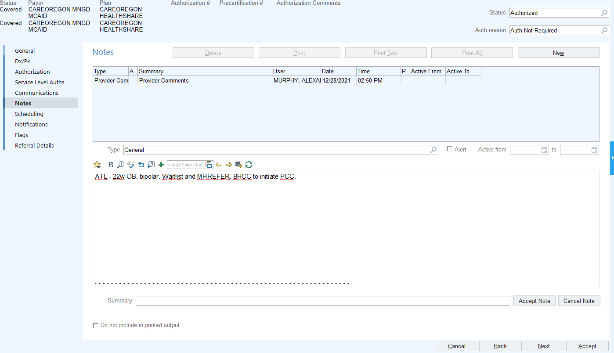
      - Patients who qualify for Perinatal Care Coordination may or may not also qualify for or desire BH and/or PMHNP care at WHA. When BH or PMHNP care is needed in addition to Perinatal Care Coordination, the BHCC indicates this in the referral review note.
    - The BHCC proceeds to Workflow E3: Case Management and follows the processes to enact Perinatal Care Coordination.
  - The patient is referred to Behavioral Health and the BHCC determines the patient requires further review for best avenue of care and initiates the Psychiatic Case Review process as indicated in Workflow F4: Psychiatric Case Review for High-Risk OB Patients
    - The BHCC reviews Behavioral Health and Psychiatric referrals for ATL/BTL criteria, Level of Care, and High-Risk Criteria indicated in Workflow E2: High Risk Criteria.
    - The BHCC determines the patients Level of Care may be beyond the scope of WHA psychiatric services and brings the patient to Psychiatric Case Review to determine the most appropriate next steps for supporting the patient which may include Perinatal Care Coordination. Refer to Workflow F4: Psychiatric Case Review for High-Risk OB Patients
  - The BHC or PMHNP interacts with a patient by way of a warm handoff, consultation, triage appointment, or follow up and determines the patient may no longer benefit from current services and requires further consideration for best avenue of care. The BHC or PMHNP recommends that the patient would benefit from Psychiatric Case Review for High-Risk OB Patients to determine the best avenue of support for the patient which may or may not include Perinatal Care Coordination.
    - There are several reasons a BHC or PMHNP would consider a patient may benefit from Psychiatric Case Review including but not limited to:
      - Patient ‘No Shows’ more than TWO BH or PMHNP appointments and becomes ineligible for reschedule.
      - Patient is already connected to a therapist in the community that they see regularly.
      - Patient is seeing the PMHNP but for any reason is unable to utilize BH services at WHA.
      - Patient does not require or desire mental health care but would benefit from case management services specific to OB/PP.
    - The BHC or PMHNP is responsible for referring the patient for Psychiatric Case Review by way of entering a ‘Referral to Behavioral Health/Behaviorist.’ The BHC or PMHNP must delete the automated form auto populated in the comment section of the referral and instead input and complete the dotphrase (.BHPCCREFERRAL)
    - The BHCC reviews the referrals for complete information, replying with requests for any missing details, and proceeds to bring the patient through Psychiatric Case Review as indicated in Workflow F4: Psychiatric Case Review for High-Risk OB Patients.

Workflow E2: High Risk Criteria
Patients who meet Level C or Level D criteria, as reviewed in Workflow F2: Level of Care are the most likely to risk out of Behavioral Health/PMHNP care at WHA and qualify as high-risk patients who may benefit from perinatal care coordination. However, some patients who meet Level A or Level B criteria may also qualify if they meet at least one of the high-risk indicators.
High Risk Indicators:
- Serious and Persistent Mental Illness (SPMI): Major Depression, Bipolar Disorders, Schizophrenia and Borderline Personality Disorder
- Psychiatric Hospitalization(s) within the last year
- Multiple Systems Involvement requiring care coordination and case management
- Interpersonal or Domestic Violence
- Significant barriers to accessing care based on social determinants of health
- Low engagement in BH/PMHNP services at WHA
- Active substance use including regular marijuana use in pregnancy
Perinatal Care Coordination is available to the following patients:
- OB/PP patients who are ‘Above the Line’ of eligibility for services as indicated in Workflow A2: Above the Line/Below the Line and Triage Decision Grid and meet at least one high-risk indicator
  - OB/PP patients who are on the BH waitlist qualify during their time on the waitlist as well as circumstantially as needed once engaged in therapy with a BHC
- OB/PP patients who may “risk out” of mental health care at WHA due Level C or D status who have moved through the Psychiatric Case Review process as indicated in Workflow F4: Psychiatric Case Review for High-Risk OB Patients and determined appropriate for services.

Workflow E3: Perinatal Care Coordination/Case Management Workflow
The BHCC engages in the following activities as part of Perinatal Care Coordination from the time of referral up to 8 weeks postpartum, or longer as needed:
- Patient Outreach every 4-6 weeks
  - Check on well-being, review current services and supports, identify gaps in services that would benefit from added referrals, and support in connection to services and supports that have lapsed
- Referrals for Community Programming
  - Utilize Perinatal Essential Services Checklist (.BHCCPCCPREGESSENTIAL) to connect patients to foundational resources
  - Send, track, and follow up on referrals to determine patient’s connection to services
- Chart Reviews
  - Identify upcoming appointments and track engagement with care
- Communication with WHA Care Team
  - Correspond with providers to update about relevant information to patient’s care or to request the provider address something with the patient during a visit
- Care Coordination
  - Engaging with care providers external of WHA, when appropriate
- Other
  - Services may vary or change depending on the patient’s need

- Patients are determined to be eligible for Perinatal Care Coordination by the BHCC.
- The BHCC completes outreach to the patient by scheduling and conducting a ‘BH Warm Handoff.’ The ‘Appt Notes’ should include ‘PCC’ to indicate the call is for Perinatal Care Coordination.
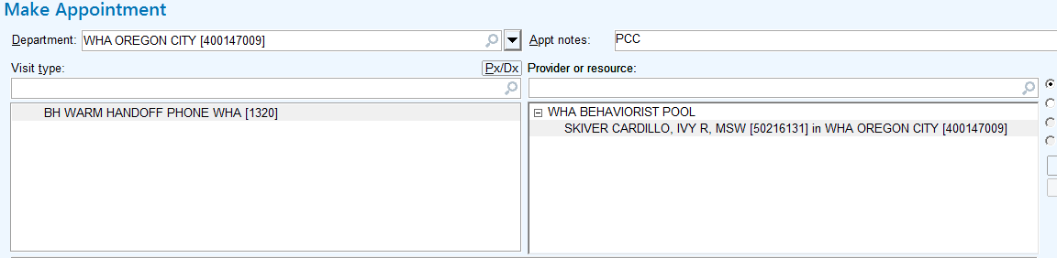
- The BHCC opens the Warm Handoff encounter from their schedule and uses the dotphrase .BHCCPCCENTRY as reference to discuss Perinatal Care Coordination services with the patient.
Scripting to Patients for entry to Perinatal Care Coordination (.BHCCPCCPT)
I am reaching out as a part of your OB care team at Women’s Healthcare Associates. The behavioral health team plays a vital role in supporting wellness during pregnancy and the postpartum transition. Based on what you have shared with us regarding some of the challenges you have experienced in your life, we want to offer perinatal care coordination to you as a part of your OB and post-partum care. This means that a trained clinical member of our behavioral health team will reach out to you every 4-6 weeks to check in on how you are feeling emotionally and if there are additional resources, services or supports we would recommend to you to feel your best during this time. There is no cost for this service, and you are also welcome to reach out to us if things come up between calls that you would like to address. Is this something you would be open to receiving?
  - If the patient is not reached after 2x attempts, the BHCC sends the scripting (.BHCCPCCPT) to the patient via a myhealth message.
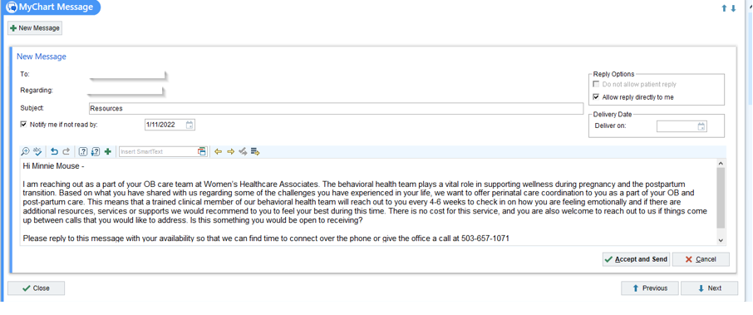
    - If the patient does not respond to outreach attempts, the BHCC will conduct chart reviews every 4-6 weeks and correspond with providers as needed in case acuity increases and the patient becomes more receptive to services.
  - If the patient declines, the BHCC will not continue with outreach calls but will conduct chart reviews every 4-6 weeks and correspond with providers as needed in case acuity increases and the patient becomes more receptive to services.
  - If the patient accepts, the BHCC completes the warm handoff which includes gathering and documenting information on patient’s mental health history, any past or current mental health services, and assesses safety using the dotphrase .BHCCPCCINITIAL
    - The BHCC schedules a ‘BH Warm Handoff’ 4-6 weeks out from point of contact based on the patient’s expressed availability and interest. The BHCC will continue scheduling patients at the point of outreach, every 4-6 weeks, for the entirety of their involvement with Perinatal Care Coordination.
      - All follow up warm handoffs conducted by the BHCC should be documented using the dotphrase .BHCCPCCFU
      - If at the time of the scheduled call, the patient does not answer, the BHCC schedules a follow up call 4-6 weeks from that point unless upon chart review or correspondence with the provider it is apparent that increased outreach attempts would be appropriate.
    - The BHCC offers the patient information and referrals from the Perinatal Essential Services Checklist which is accessible within the initial warm handoff note using dotphrase .BHCCPCCINITIAL. This list includes information for accessing and referring to foundational services such as home visiting, doulas, parenting resources, etc. It is referenced and reviewed during each interaction with the patient as needs and interests change throughout perinatal period.
- The BHCC informs the patient's WHA referring medical provider/care team of the patient’s engagement in Perinatal Care Coordination by sending a staff message using the following .dotphrase .BHCCPCCPROVIDER with scripting:

Scripting to Providers after entry or declining of Perinatal Care Coordination (.BHCCPCCPROVIDER)
Thank you for referring this patient to Behavioral Health.

Based on chart reviews, outreach with the patient, and/or referrals to behavioral health, your patient may be best supported by the following services provided internally at WHA:
- Perinatal Care Coordination by the BHCC: pt accepts/declines
- Behavioral Health Therapy: pt accepts/declines
- PMHNP care: pt accepts/declines/pt requires a higher level of psychiatric care than is offered at WHA
Additionally, we will support your patient in connecting to these additional services and supports outside of WHA:
- Maternal-Child Health Home Visiting: pt accepts/declines
- Community Mental Health Services: list facility and program or service and if accept or decline
- Engagement with county crisis services:
- Referral to Care Management: if available through CCO pt is assigned
- Other:

Perinatal Care Coordination involves routine outreach, to patients who accept it, to address barriers to accessing additional services and support in the community. This outreach will continue throughout the pregnancy and up to 8 weeks postpartum, or longer if necessary. You will find documentation of outreach to this patient in phone notes in their chart, which will be routed to you with relevant updates, as well as in the associated problem overview and care coordination note.
If the patient declines perinatal care coordination, chart review and outreach to patient's primary OB provider(s) will be conducted to make recommendations for resources and supports that could be offered to the patient by the OB provider.

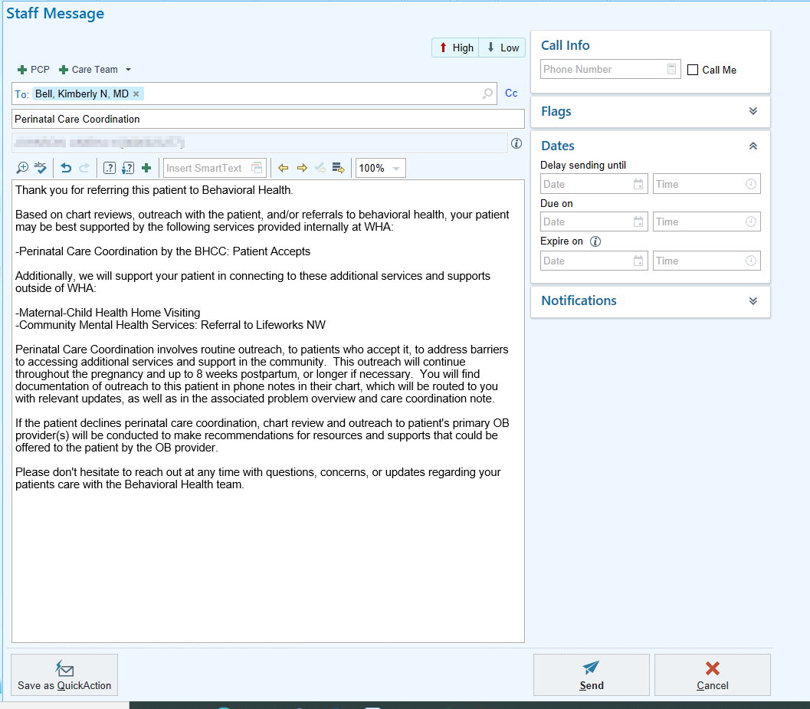

- The BHCC adds the patient to the ‘OB Care Coordination’ tab of the Excel spreadsheet ‘BH Caseload and Referral Workflow’ which is accessible on the shared P Drive by following: P:\Behaviorist\Public\Workflows\Caseloads.
  - The spreadsheet is organized by annual quarters with patients sorted by Estimated Delivery Date. As the patient’s care progresses to the postpartum period or is completed, the patient moves on the spreadsheet to the affiliated sections.
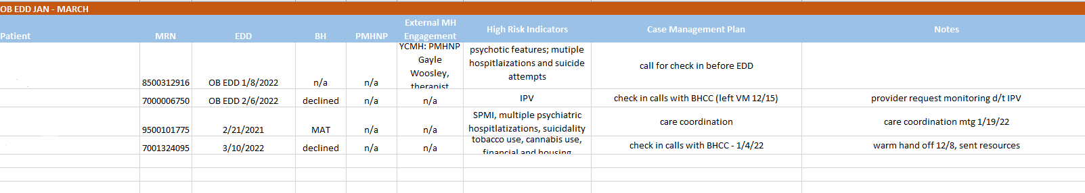
  - The BHCC is responsible for tracking Perinatal Care Coordination patients who are currently experiencing active substance use for annual funding from Care Oregon Value-Based Payments. For those who have active substance use concerns, the BHCC tracks whether they utilize Oregon Health Plan for insurance coverage.
    - Within the ‘OB Care Coordination’ tab of the ‘BH Caseload and Referral Workflow, the BHCC places a check mark in the ‘Substance Use’ Column if the patient meets the criteria of active substance use. For those who have active substance use, a check mark is placed in the ‘OHP?’ Column if the patient is using OHP insurance.
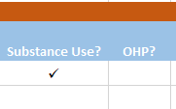
- The BHCC documents the patient’s engagement in Perinatal Care Coordination in the patient’s chart in the following areas after each interaction on behalf of or with the patient:
  - Problem Overview
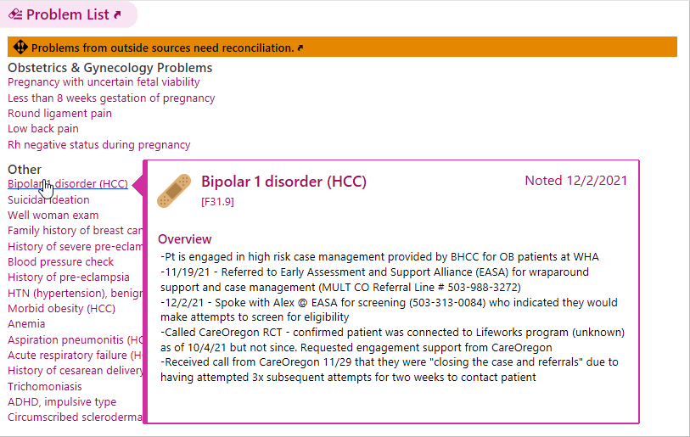
  - Care Coordination Note
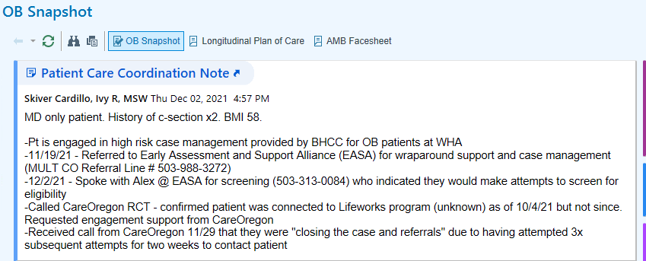
  - Case Management Notes
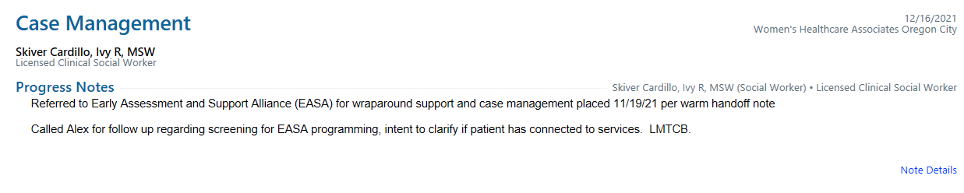
  - Warm Handoff Notes
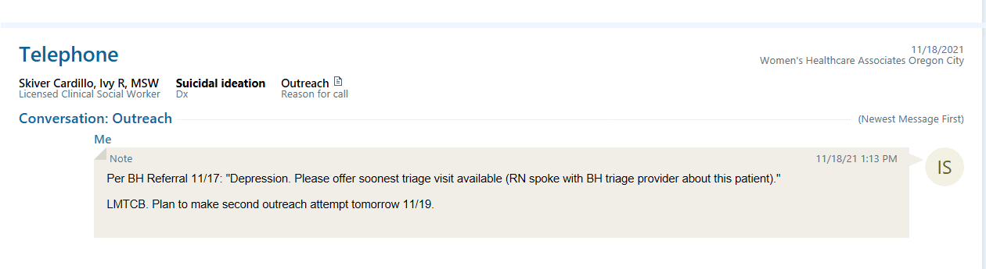
- When patients move from the BH waitlist to the caseload of BHC or go from low/no engagement to regular attendance at BH appointments, the BHC becomes primarily responsible for case management of that patient. The patient remains on the OB Care Coordination spreadsheet and the BHCC continues to conduct monthly chart reviews of the patient in order to maintain awareness of any changes to engagement or access to care.
  - If a patient has been working with a BHC but the patient stops attending or scheduling visits, the BHC may reach out to the BHCC for additional support in care coordination. At this point, the BHCC may decide to bring the patient to, or back to, Psychiatric Case Review to determine the best course of action.
- Perinatal Care Coordination is complete upon patients' attendance at their 8w postpartum visit with their OB provider after which point the BHCC completes one final outreach to wrap care and provider any final referrals or resources needed. Upon final outreach, they are moved to the ‘Completed’ section of the OB Care Coordination tab in the Excel spreadsheet ‘BH Caseload and Referral Workflow.’

PMHNP Workflows

Section F: Entry to PMHNP Care

Workflow F1: Referral to BH with PMHNP request by medical provider
The Behavioral Health Care Coordinator (BHCC) receives internal referrals for Psychiatry and referrals to Behavioral Health with requests for psychiatry services in the “Behavioral Health Referral Order” workqueue. All referrals requesting psychiatric services are reviewed for ATL/BTL criteria and action as indicated in workflow F3.
Medical providers must complete a ‘Referral to Behavioral Health/Behaviorist’ requesting psychiatric services for assessment. The BHCC then places a ‘Referral to Psychiatry, BH Dept Use Only’ based on the behavioral health referral and reviews it according to Workflow F3: Level of Care.
- The BHCC receives the ‘Referral to Behavioral Health/Behaviorist’ requests from medical provider in the “Behavioral Health Referral Order” workqueue.
- Within the ‘Referral to Behavioral Health/Behaviorist’ request, providers are required to complete comprehensive information surrounding their patient’s need for psychiatric services necessary for scheduling. The referral to BH with psychiatric questions is as follows:
Mark referral urgent if priority review.
Patients not meeting criteria for mental health care at WHA due to capacity or acuity will receive referrals, please prepare your patient for this.
Capacity for most services at this time has been limited to OB and up to 6 mos PP.

What services is your patient open to receiving?
Diagnosis or Referral Problem:
Are you referring for psychiatric medication services with WHA PMHNP? Yes
Have you assessed the patient for psychiatric illness? Yes
What is your diagnosis: ***

Have you initiated a psychiatric medication? Yes
Are you requesting a transfer of medication management to the WHA PMHNP? Yes
List Reason for Transfer of Care: ***

Is the patient receiving psychiatric medications from a provider external to WHA? Yes
Please list:
Name and Facility of Psychiatric Prescriber: ***
Psychiatric Diagnosis if known: ***
Reason for transfer of care request: ***

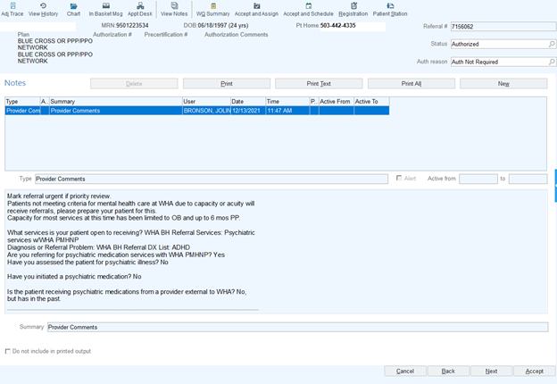
  - The BHCC reviews the referral in accordance with Workflow F3: Level of Care with particular attention to the patient’s current psychiatric medication prescriber.
    - If the WHA provider is prescribing medication, they must include a reason for transfer for the referral to be processed for action.
    - If there is an external provider prescribing medication, the referring provider must include the name/facility of the prescriber and the reason for transfer for the referral to be processed for action.
  - If the patient is being referred for psychiatric services by a provider and is currently engaged with a BHC for therapy, the BHCC enters the ‘Referral to Psychiatry’ as a case management note (as described below) and routes this to the BHC. The intent of the message is to notify the BHC of the referral request by the provider and to indicate that the BHCC has placed a ‘Referral to Psychiatry, BH Dept Use Only’ on behalf of the patient.
  - If the patient is being referred for psychiatric services by a provider but is not engaged with a BHC for therapy, the BHCC must determine if the referral is appropriate to be processed for scheduling. The BHCC conducts a comprehensive chart review for the patient and will do a warm handoff outreach with the patient directly if further information is needed to determine appropriateness for psychiatric care at WHA.
  - If the patient is deemed inappropriate for psychiatric services at WHA, the BHCC sends an in-basket message to the referring provider indicating the reason that patient does not qualify as well as indicating any other follow up or outreach/support services the BHCC will provide such as OB Care Coordination if necessary.
- When a patient is deemed appropriate for psychiatric services at WHA, The BHCC enters the ‘Referral to Psychiatry, BH Dept Use Only’ on behalf of the patient by going to the patient’s chart and selecting ‘Encounter.’
    - The BHCC selects ‘NEW’ in the pop-up window and fills in the ‘Type’ of encounter as ‘Case Management.’
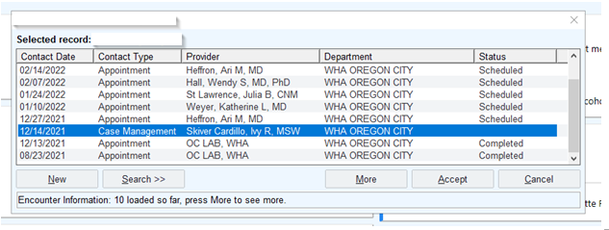
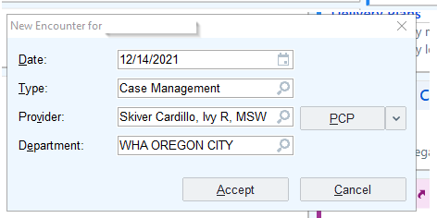
    - Within the documentation section of the Case Management encounter, the BHCC enters the dotphrase .BHCCPSYCHREFNOTE and completes the required information including the contents of the Behavioral Health referral and any pertinent information gathered from the chart review.
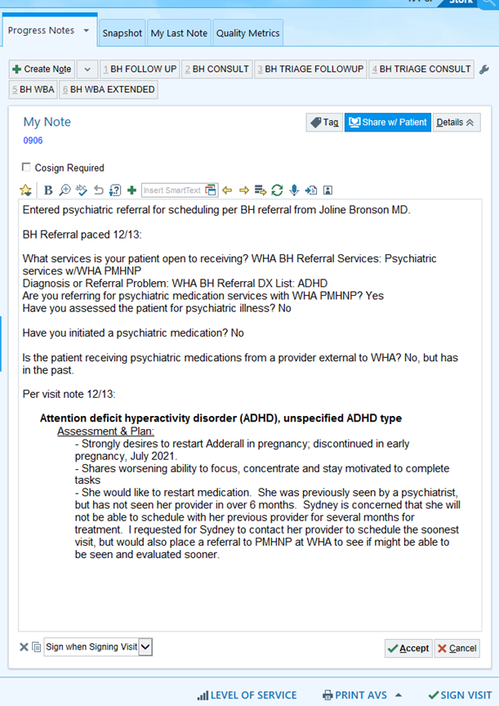
    - The BHCC places the new referral by clicking ‘Add Order’ and selecting ‘Referral to Psychiatry, BH Dept Use Only.’
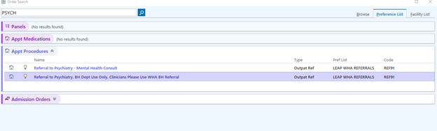
    - The BHCC completes the psychiatric referral order using information from the Behavioral Health referral, visit notes, and a comprehensive chart review.
      - If any information necessary for the psychiatric referral is missing from the Behavioral Health referral, the BHCC sends a message to the provider requesting the specific information needed.
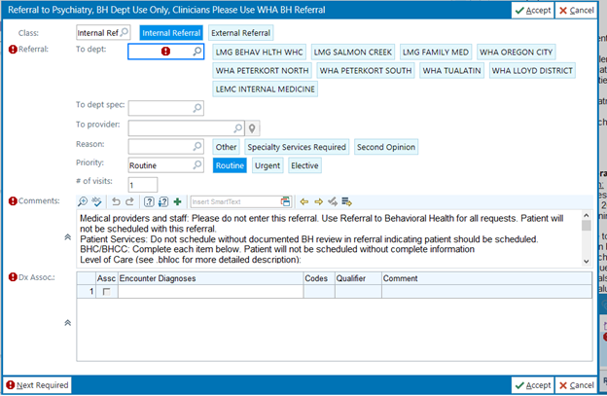
    - The BHCC clicks ‘Sign Order’ which initiates a request for the BHCC to link the order to an affiliated problem from the problem list. The problem that is most relevant to the referral is attached to the order.
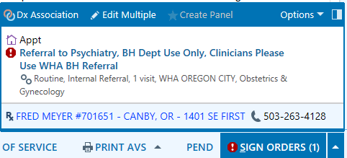
    - The ‘Order Mode’ must be filled in as ‘AMB Scheduled Ord Protocol’ and the Authorizing Provider is listed as the Referred by Provider from the original Referral to Behavioral Health/Behaviorist.
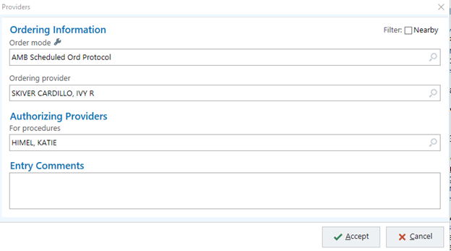
    - If engaged with Behavioral Health, the BHCC routes the case management note to the BHC the patient is seeing.
    - Upon signing the case management encounter note, the referral will be sent to the workqueue where the BHCC will review the referral for action using Workflow F3: Level of Care.
    - The BHCC places a note in the original ‘Referral to Behavioral Health/Behaviorist’ as indicated in the Behavioral Health Referral Workflow A1 indicating that they have entered a ‘Referral to Psychiatry’ based on the providers request using the dotphrase .BHCCPSYCHREFREVIEW
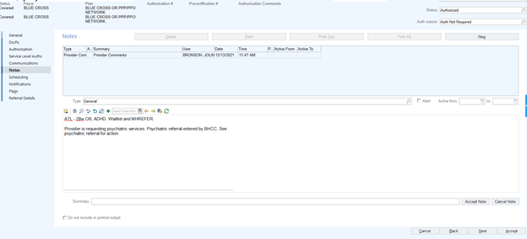

Workflow: Requesting Previous Psychiatric Records : In Progress

Workflow F2: Referral to Psychiatry by BHC/BHCC
- Referrals may be placed directly to psychiatry by BHCs/BHCCs by completing the ‘Referral to Psychiatry, BH Dept Use Only.’
- The BHCC receives the ‘Referral to Psychiatry, BH Dept Use Only’ requests from BHCs/BHCCs in the “Behavioral Health Referral Order” workqueue.
- Within the ‘Referral to Psychiatry, BH Dept Use Only’ request, therapists are required to complete comprehensive information surrounding their patient’s need for psychiatric services necessary for scheduling. The referral to psychiatry questions are as follows:
Medical providers and staff: Please do not enter this referral. Use Referral to Behavioral Health for all requests. Patient will not be scheduled with this referral.
Patient Services: Do not schedule without documented BH review in referral indicating patient should be scheduled.
BHC/BHCC: Complete each item below. Patient will not be scheduled without complete information
Level of Care (see .bhloc for more detailed description):
What level of care designation best fits this patient? Level A

Level of Care Brief Descriptions below. Detailed LOC descriptions here: https://careoregon.org/docs/default-source/providers/behavioral-health/bh-forms/loc-adult-initial-treatment-reg-form-1957703-1223-fillable.pdf?sfvrsn=ce6dc3b9_4

If patient currently has a WHA provider prescribing psychiatric medications, that provider must enter a ‘Referral to Behavioral Health/Behaviorist’ requesting a transfer of medication management. Please coordinate this with the WHA provider and delete this referral.

Does patient currently have a non-WHA provider prescribing their psychiatric medications? Yes
Name and Facility of Psychiatric Prescriber: ***
Psychiatric Diagnosis if known: ***
Reason for transfer of care request: ***
ROI is mandatory for external mental health providers not visible in EPIC. Please prepare your patient for record request.

Reason for Referral:
Psychiatric Evaluation: All patients referred into psychiatric care receive a psychiatric evaluation. Why will this patient benefit from this? History of severe mental illness: describe *** / Persistent or worsening symptoms: describe*** / Not responsive to psychotherapy: describe interventions*** / Need dx clarification: describe any rule outs you suspect ***

Medication Management: Not all patients referred into psychiatric care will choose to engage in medication management with a WHA psychiatric provider. Provide information regarding if this patient wishes to receive medication management from a WHA psychiatric provider: Patient is taking *** (list medication) and wishes to transfer care to PMHNP at WHA because*** / If medication is recommended patient states they are open to it / Patient is uncertain if they will accept medication recommendations but would like an evaluation and recommendations / Patient is certain they will not accept medication but would like an evaluation and recommendations

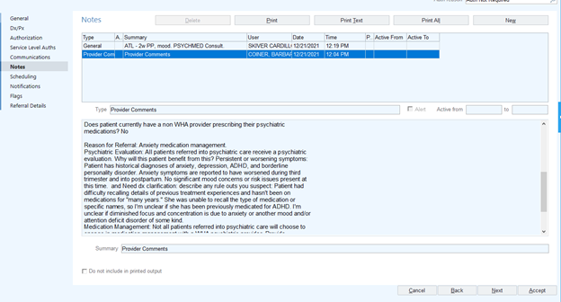

- The BHCC reviews the referral in accordance with workflow F3 with particular attention to the patient’s current psychiatric medication prescriber.
  - Referrals to Psychiatry by BHCs are not accepted if the patient is currently being prescribed psychiatric medication by a WHA provider. The WHA provider must enter a Referral to Behavioral Health/Behaviorist requesting a transfer of care and reason for transfer as described in Workflow F1b: Referral to BH with PMHNP request by medical provider. It is the BHCs responsibility to coordinate this.
    - If a Referral to Psychiatry is placed by a BHC and a WHA provider is prescribing medication, the referral is sent back to the BHC requesting that the BHC consult with the WHA provider by sending the BHC an in-basket message from the referral shell. This referral would then be void and action can be indicated as “No action needed. Please close referral.”
  - If there is an external provider prescribing medication, the BHC must include the name/facility of the prescriber and the reason for transfer for the referral to be processed for action. The BHCC indicates in the review process that the BH PSR must request an ROI to acquire records.

Workflow F3: Level of Care
Referrals to psychiatry require assessment of ‘Level of Care’ to adequately be reviewed. The BHC/BHCC is responsible for assessing the patient and conducting a thorough chart review in order to determine appropriate Level of Care and signifying this in the ‘Referral to Psychiatry, BH Use Only’ form. Patients who meet Level A/Level B criteria are often seen within WHA while patients who meet Level C/Level D require more comprehensive care in the community. However, Level C and Level D patients must be moved through the Psychiatric Case Review process to determine the best avenue of care.
The Level of Care Determination Criteria used is from the Authorization Form for Care Oregon Adult Mental Health which can be accessed in its entirety here: loc-adult-initial-treatment-reg-form-1957703-1223-fillable.pdf (careoregon.org).

Level of Care Determination Criteria
Level A Criteria:
This patient meets criteria for Level A Mental Health Outpatient if they are experiencing:
- Episodic depression, anxiety or other mental health conditions with no recent hospitalizations and limited crisis episodes in past year
AND at least one of the following:
- Mild functional impairment
- A presentation that is elevated from baseline
Concurrent clinical considerations:
- Capable of additional symptom or functional improvement at this LOC
- significant cultural and language barriers impacting ability to fully integrate symptom management skills and there is no more clinically appropriate service
Examples: Mild depression or anxiety that cannot be addressed only by primary care intervention • A client who is precontemplative regarding engagement in a higher LOC
Level B Criteria:
This patient meets criteria for Level B Mental Health Outpatient if they are experiencing one or more:
- Moderate risk of harm to self or others
- Moderate functional impairment in at least one area such as housing, financial, social, occupational, health, and activities of daily living
- Individual has a marginalized identity that creates barrier to receiving appropriate services, and/or individual's level of English language skills and/or cultural navigation barriers is not sufficient to achieve symptom or functional improvement without additional supports
Examples: Moderate risk of harm to self or others requiring more frequent sessions • A client who is precontemplative regarding engagement in a higher LOC • Individual is stepping down from higher LOC and demonstrating symptom or functional improvement • Individual's clinical presentation is affecting at least one functional domain such as work or relationships and therefore would benefit from more frequent services
Level C Criteria:
This patient meets criteria for Level C Mental Health Outpatient if they are experiencing an ABL dx and at least 2:
- Risk of harm to self or others, or risk of harm to self or others that is escalated from baseline
- Moderate functional impairment in at least two areas (such as: housing, financial, social, occupational, health and activities of daily living)
- At least one hospitalization in the last 6 months
- Multiple system involvement requiring coordination and case management
- Risk of loss of current living situation, in an unsafe living situation or currently experiencing homelessness due to symptoms of mental illness
- Significant PTSD or depression symptoms as a result of torture, ongoing systemic oppression, trauma or multiple losses
- Extended or repeated crisis episode(s) requiring increased services
- Individual has a marginalized identity that creates barriers to receiving appropriate services, and/or individual's level of English language skills and/or cultural navigation barriers is not sufficient to achieve symptom or functional improvement without additional supports
- Diagnosis and/or age-related functional deficits and/or complex medical issues requiring substantial coordination
Examples: Mental health issues are compounded by risk of loss of housing due to extended periods of crisis • Individual may benefit from care coordination and case management • A client who is precontemplative regarding engagement in a higher LOC
Level D Criteria:
This patient meets criteria for Level C Mental Health Outpatient if they are experiencing an ABL dx and at least 2:
- Two or more inpatient admissions in the past year
- Recent discharge from the state hospital (within the past year)
- Civil commitment or discharge from the state hospital (within the past year)
- Residing in an inpatient bed or supervised community residence and clinically assessed to be able to live in a more independent living situation if intensive services are provided
- Severe deficits in skills needed for community living as well as a high degree of impairment due to symptoms of mental illness
- Significant PTSD or depression symptoms as a result of torture, ongoing systemic oppression, trauma or multiple losses
OR at least three of the following:
- Intractable, severe major symptoms
- Significant cultural and linguistic barriers exist
- Significant criminal justice involvement
- Requires residential placement if intensive services are not available
- Not engaged in services but deemed at high risk of harm related to their mental illness
- Severe deficits in skills needed for community living as well as a high degree of impairment due to symptoms of mental illness
- Co-occurring addiction diagnosis
- Risk of loss of current living situation, in an unsafe living situation, or currently experiencing homelessness due to symptoms of mental illness

Workflow F4: Review of Referral to Psychiatry
- The Behavioral Health Care Coordinator (BHCC) receives internal referrals for Psychiatry in the “Behavioral Health Referral Order” workqueue. Referrals that have a status of “Ready for Initial Scheduling” require review, attending to those with an “urgent” level of priority first. The BHCC incorporates information from provider comments, eligibility decision grid, and a thorough chart review to determine appropriate action. Referrals are typically reviewed the same day as they are entered unless entered very late in the day.
- BHCC conducts a thorough review of patient information to determine above the line (ATL)/below the line (BTL) criteria for eligibility of Psychiatric Services.
  - Of particular interest are relevant clinical data such as medications, diagnoses, WBA/EPDS data, and recommendations (WL, triage, refer) included in the ‘Provider Comments’ section of the referral notes.
  - The BHCC pays attention to the LEVEL OF CARE indicated by the BHC/BHCC in the referral as this heavily impacts eligibility for psychiatric care.
- The referral must be completed in its entirety for it to be effectively reviewed and processed for action.
  - If pertinent information is missing from the referral, the BHCC contacts the referring provider by sending an ‘In Basket Message’ from the Referral Shell requesting the missing information and indicating its necessity to proceed with scheduling. The dotphrase .BHCCREFCLARITY is available for use.
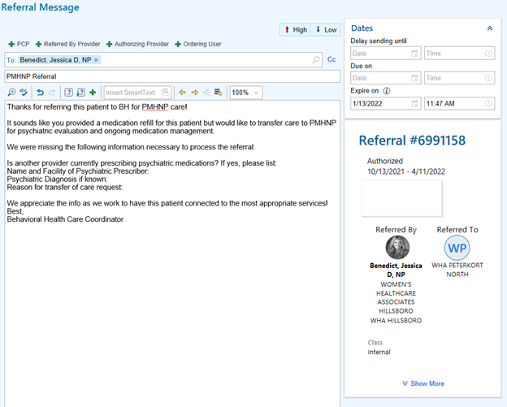
- When all information has been provided and patient information has been reviewed, the BHCC determines eligibility status by referring to Workflow A2: Above the Line/Below the Line and Triage Decision Grid.
  - For referrals that meet Above the Line criteria, Level of Care is deterministic of action:
    - Patients who are LEVEL A or LEVEL B may be offered Above the Line actions.
    - Patients who are LEVEL C or LEVEL D must be moved through the Psychiatric Case Review process to determine appropriate care options.
      - BHCC places ‘General’ note in the Referral Shell indicating that referral is ON HOLD – Psychiatric Case Review along with the date the patient will be discussed in review.
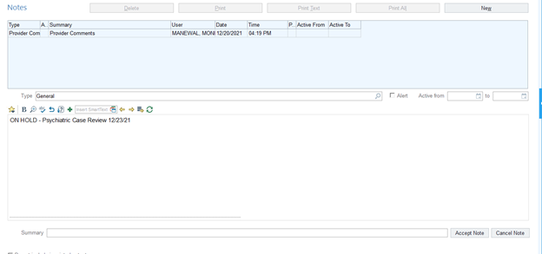
      - Refer to Workflow F4: Psychiatric Case Review for processes.
      - Once consultation has been completed, the referral progresses as either ATL or BTL as usual. The BHCC proceeds to step 5 as well as sends an ‘In Basket Message’ within the Referral Shell to ‘WHA Patient Services Behavioral Health Pool’ with updated eligibility and action.
Options for action instructions are based on eligibility:
Above the Line options to note in referral instructions to PSR:
  - PSYCHMED CONSULT – Transfer of Care w/Med Management
  - PSYCHMED CONSULT – Psychiatric Eval w/Med Management
  - PSYCHMED CONSULT – Diagnostic Clarification w/ or w/o Med Management
  - TRIAGE, PSYCHMED CONSULT
    - Transfer of Care w/Med Management
    - Psychiatric Eval w/ Med Management
    - Diagnostic Clarification w/ or w/o Med Management
Below the Line options to document in referral instructions to PSR
  - Referral Resources (.WHAMHREFER) & (.PMHNPCOMMERCIAL)
  - Any specific information or referrals in addition to standard

- Some patients referred to psychiatry will be actively or will have recently been engaged in psychiatric care and be recommended for a transfer to the WHA PMHNP. In these cases, it is necessary to attempt to collect current and historical psychiatric records. The BHCC is responsible for determining the need for ROIs/record requests and making the request to the BH PSR. The BHCC determines the need for ROI/records based on the following:
  - If the provider currently prescribing medication is a WHA provider, all records are available and no ROI or records are needed.
  - If the provider currently prescribing medication is external of WHA and records are viewable in EPIC ‘Care Everywhere’, no ROI or records are needed.
  - If the provider currently prescribing medication is external of WHA and records are *not* viewable in EPIC, an ROI and records are requested alongside scheduling.
    - The BHCC makes a request in the referral review note of the referral shell indicating the need for ROI and records.
    - Note: Records for Level A and Level B are encouraged for scheduling but not required. If records are required for scheduling, the BHCC would indicate that in the referral review note.
- The BHCC creates a new ‘General’ note in the Referral Shell indicating pertinent information gathered from the review, ATL/BTL status, LOC, as well as action instructions for the BHPSR. BHCC “accepts” the note changes and returns to workqueue list.
  - For example: “ATL – 14w OB, perinatal mood. PSYCHMED CONSULT – Transfer of Care w/Med Management. Please request ROI for Minnie Mouse PMHNP at Western Psych.”
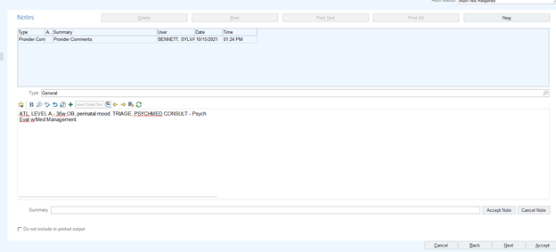
- BHCC right clicks on the patient and selects “notes.” The note must have a summary of status or plan using the following options: “ATL,” “BTL,” or “Wait for Action.” Once accepted, this note will add a “Yes” in the far-left column, notifying the BH PSR that the referral is ready to be called and offered the services outlined.
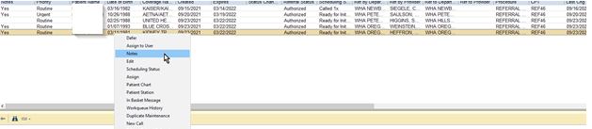
- Once the BH PSR has completed the workflow and conducted outreach for scheduling but has been unsuccessful in contacting the patient, the BH PSR follows the workflow that indicates closing the referral. The BH PSR sends a message stating ‘FYI closing referral’ to the BHCC to notify of all referral closures for ATL patients. The BHCC receives these messages in the EPIC ‘Referral Messages’ pool.
  - The BHCC conducts a brief chart review of the messages to determine if extenuating circumstances apply in which the patient may be contacted outside of the regular workflow or if notifying the provider of the unsuccessful attempts for contact is necessary.
  - If the BHCC determines the referral closure is appropriate and no further action is needed, the BHCC deletes the message.
  - If the BHCC determines that the provider would benefit from information regarding the closed referral, the BHCC forwards the FYI message to the ‘Referred by Provider’ using the .dotphrase BHCCREFCLOSE.

Workflow F5: Psychiatric Case Review for High-Risk OB & PP Patients

Entry into Psychiatric Case Review
- The BHCC reviews ‘Referrals to Psychiatry, BH Use Only’ in the workqueue as indicated in Workflow F4: Review of Referrals to Psychiatry with the intent of identifying referrals marked LEVEL C or LEVEL D. Referrals that indicate a patient requires LEVEL C or LEVEL D care, it is necessary for the patient to move through the Psychiatric Case Review Process in order to determine appropriate avenues of care.
- The BHCC places a ‘General’ note in the Referral Shell indicating that referral is ‘ON HOLD – Psychiatric Case Review’ along with the date the patient will be discussed. For example: ‘ON HOLD – Psychiatric Case Review 12/23/21’
  - The BHCC then defers the referral until the date of the Psychiatric Case Review in which the patient will be discussed in order to remove it from the workqueue.
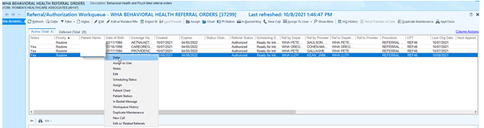
  - The deferment ‘Reason’ is marked as ‘Future Referral’ and dated to return to the workqueue on the date of the Psychiatric Case Review in which the patient will be discussed. A note is placed in the deferment indicating ‘ON HOLD- Psychiatric Case Review’ along with the date the patient will be discussed.
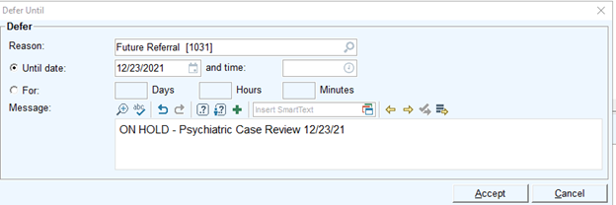

- The BHCC is responsible for collecting relevant records necessary for psychiatric case review.
  - The BHCC reviews the patient’s chart to determine if necessary records are accessible in Care Everywhere in EPIC.
  - When records are not available internally, the BHCC sends an ‘In-Basket Message’ from the referral to the ‘WHA Patient Services Behavioral Health Pool’ requesting the BH PSR initiate action to have the patient complete an ROI to request records from any previous or current psychiatric or specialty mental health providers that were listed in the ‘Referral to Psychiatry, BH Dept Use Only.’
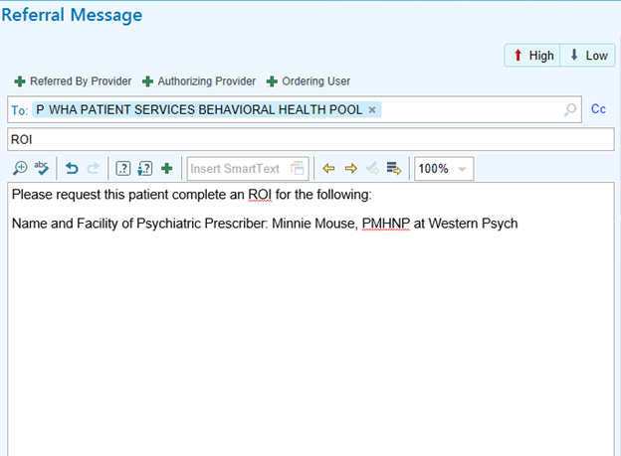

Psychiatric Case Review
Purpose of case review: Establish a consistent referral review process for above the line patients referred to WHA psychiatric provider meeting Level C or D criteria or those with active substance abuse. May also be used for patients not referred into psychiatry needing review to determine best plan of care (example: complex patients who have seen a BHC and BHC is recommending review)

Roles in case review:
- Facilitator (BHC lead/dir): Starts and ends meeting on time, facilitates following established meeting format, assists BHCC with notetaking in case document in teams, supports decision-making
- BHCC: Complete referral review and facilitate records requests, sends out case write up in email 24 hours prior to each review/notifies facilitator to cancel review if no agenda items, ok to proceed with review without full records but may not fully decide without records, communicate back to patients about process and plan, take notes
- Psychiatric Provider: Provides expert consultation and input on cases, makes recommendations regarding level of care
- BHC/other stakeholders: invited when involved/requested

The case reviews should provide the opportunity for and have the expectations of:
1. Identify case review purpose/practices/guidelines
2. Create and review guiding principles
3. Evaluate how things are working at the present time with the case review process
4. Review/update processes
5. Ask questions and be able to express when we do not know or feel uncertain about something
6. Bring a positive problem-solving attitude to each meeting.
7. Everyone will engage in active participation and will allow everyone to contribute.
8. Respect differences and avoid discounting others’ opinions
9. Support one another as we discuss difficult situations
10. Start and end meeting on time
11. Notify the meeting facilitator of any absence from a scheduled review 48 hours or more prior to meeting
12. If a designated Team member cannot attend a scheduled case staffing, a designee for each role may be assigned and will come prepared to staff the case in their absence.
13. If someone misses a meeting or must leave early, the facilitator will be designated to provide the missed information to the absent team member.
14. Cases should not be reviewed for psychiatry outside of the case review format. A request for an urgent meeting will be needed if time pressure is a factor

- The BHCC is responsible for managing the scheduling, planning, invitations, and documentation for Psychiatric Case Review. When a patient has been identified as requiring Psychiatric Case Review and records have been requested, the BHCC must prepare the documents for the review meeting and invite all stakeholders to the meeting.
  - In situations in which there are no patients to review at an upcoming scheduled Psychiatric Case Review, the BHCC must send an email to all parties cancelling the meeting with 48hours notice.
- All documents, forms, and consultation notes necessary for Psychiatric Case Reviews are stored in the Teams App within the Behavioral Health Team Channel: High Risk Mental Health OB Workflow. The file folder title ‘Psychiatric Case Review’ stores the ‘Patient Form for Psychiatric Review’ template document as well as the ‘Guidelines for Case Review.’ Each scheduled Psychiatric Case Review has its own dated folder in which the completed patient form will live for group review and future reference.
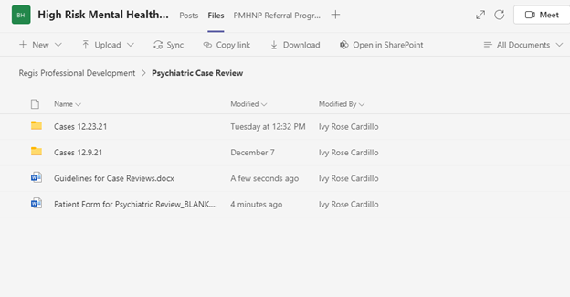
- The BHCC compiles information about the patient from chart reviews, case notes, referrals, and records to complete the “Patient Form for Psychiatric Review” as comprehensively as possible. Completed forms for each individual patient intending to be discussed during the consultation are sent, via email within the Outlook invite, to the review team (BHC, Director, PMHNP, Stakeholders—including any BHCs involved and OB providers if needed) 48hrs prior to the case review meeting.
- During the meeting, the BHCC provides a brief overview of the cases for review and asks questions of the review team regarding the best possible avenues of support for the patient. The BHCC must take notes on the meeting with particular attention to completing the section on next steps and assignment of tasks.
  - At times, it will be determined that the patient should be discussed further at a future dated consultation. The BHCC includes this as part of action steps and brings an updated version of the ‘Patient Form for Psychiatric Review’ to subsequent reviews as needed.
- The outcome of the Psychiatric Case Review will vary, and services can include BH, PMHNP, Perinatal Care Coordination, Referrals, or a combination of several services. The BHCC completes the referral review in accordance with Workflow F4: Review of Referrals to Psychiatry with the updated action and proceeds with workflows affiliated with those services.

Section H: Behavioral Health Program Goals & Roles

Part I: Behavioral Health Program Statement:

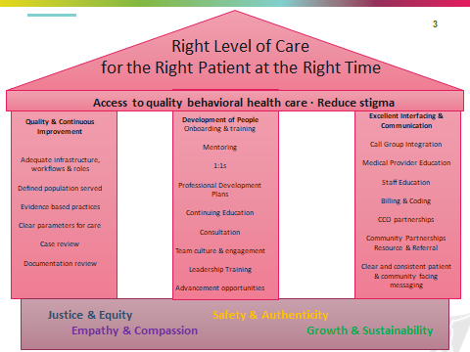
In an ideal world all people would have access to timely mental health care that is of high quality and provided in a manner that is accessible and demonstrates awareness of cultural, spiritual, psychological and social factors that impact well-being. The provision of high-quality mental health care in a medical setting sends a clear message that mental health can and should be a priority in health care, thereby reducing stigma associated with accessing care.
At WHA we hope for a future when there exists adequate funding, infrastructure, and trained personnel to serve all patient mental health needs that fall within the scope of an outpatient setting. At this time, we are forced to limit the population that we serve to:
- Pregnant patients including SAB, TAB, options counseling, neonatal loss
- Post-partum patients: referral up to 6 months post-partum
- Non-pregnant and post-partum patients needing tobacco cessation counseling in order to access elective surgery
This limitation is due to the size of our behavioral health team in comparison to the size of our patient population. With this in mind, the WHA Behavioral Health team strives to be good stewards of scarce mental health resources by adhering to a defined episode model of care to help maintain access for our patient population. A defined episode of behavioral health therapy at WHA can be understood as:
- Occurring upon referral from a medical provider in relation to a physical health issue cared for by that provider
- Occurring within a clearly communicated time frame or number of visits—typically 6-8 months or 10-15 visits
- Visits occurring every 2-3 weeks with decreasing frequency toward the end of the episode of care with options for more frequent visits during times of urgent need
The services provided within this episode of care may include:
- Psychotherapy focused on the following:
- Better understanding patterns in relationships that increase isolation and sense of not being understood particularly in the transition to parenthood
  - Identifying and learning ways to communicate that improve the quality of support received from others including asking for help clearly and saying no
  - Identifying negative thought patterns that contribute to anxiety and depression and learning skills to shift into more helpful thought patterns
  - Developing a coherent narrative that helps to include grief, loss and trauma in a way that decreases negative impact on functioning
- Psychoeducation
  - The role of sleep, support system, time to care for self in feeling well post-partum
  - Basics of maintaining optimal mental health
- Referrals to additional resources including care for high acuity needs that cannot be met in the clinic setting
- Psychiatric diagnostic interviews and medication management (Psychiatric care may exceed typical number of visits/time frame stated above)
Patients who do not wish to receive care within this model will receive referrals and assistance in accessing care that meets their needs and preferences.
Patients whose needs require more frequent appointments or more intensive supports will receive referrals and assistance in accessing care that matches their needs and preferences.

Link to BHC Job Description
Link to Lead Behavioral Health Clinician Job Description

Link to PMHNP Job Description

Link to BHCC Job Description

Link to BH PSR Job Description Link to HR job description

Return to Top

